Knowledge Organiser – Year 2 – PSHE/RSE
– Relationships – What makes a good friend?
– Friendships; feeling lonely; managing arguments
What do I already know? | 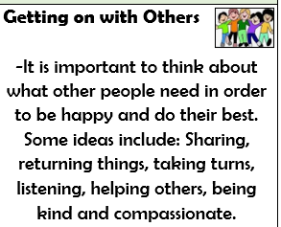  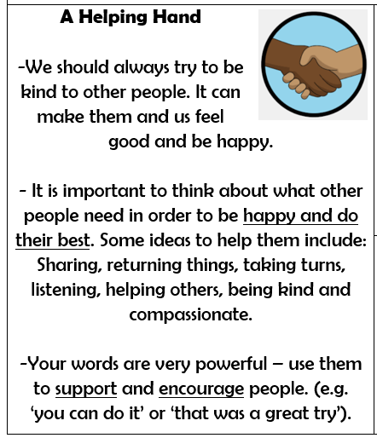
- We are all special. We have some things that make us similar to other people, and some things that make us different to other people
- It is nice for us to spend time with other people. Sometimes, we also like to be alone.
- We have many different feelings, e.g. happy, sad, excited, disappointed and angry.
- There are ways that we can help ourselves feel better. Sometimes, other people can also help us to feel better too. Different people can help us at different times.
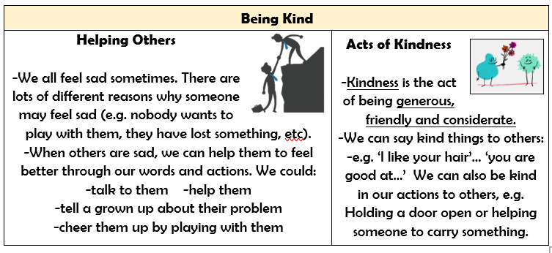

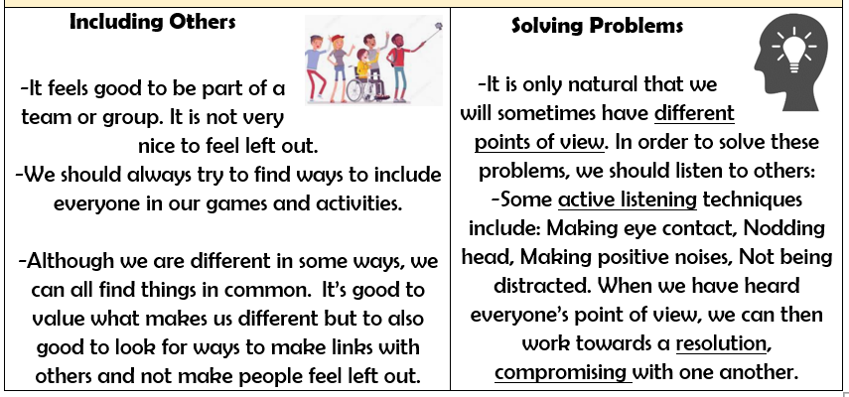

What should I be able to do at the end of the topic?
- How to make friends with others
- How to recognise when I feel lonely and what I could do about it
- How people behave when they are being friendly and what makes a good friend
- How to resolve arguments that can occur in friendships
- How to ask for help if a friendship is making me unhappy
 | Key Vocabulary

