Knowledge Organiser – Year 1 – PSHE/RSE
– Living in the Wider World – How can we look after each other and the world?
– Ourselves and others; the world around us; caring for others; growing and changing
What do I already know? | 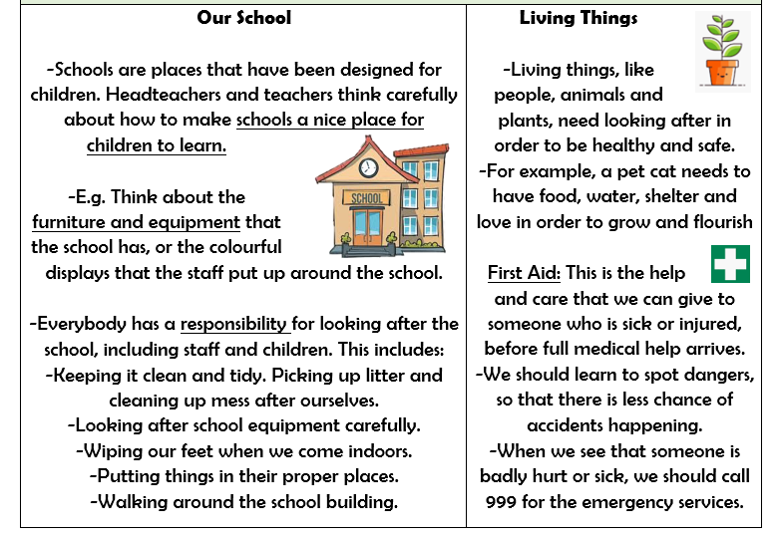  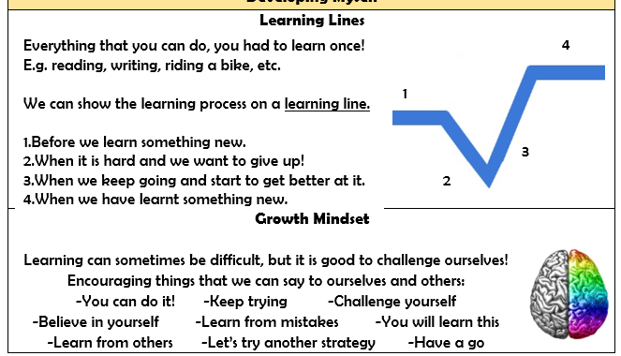  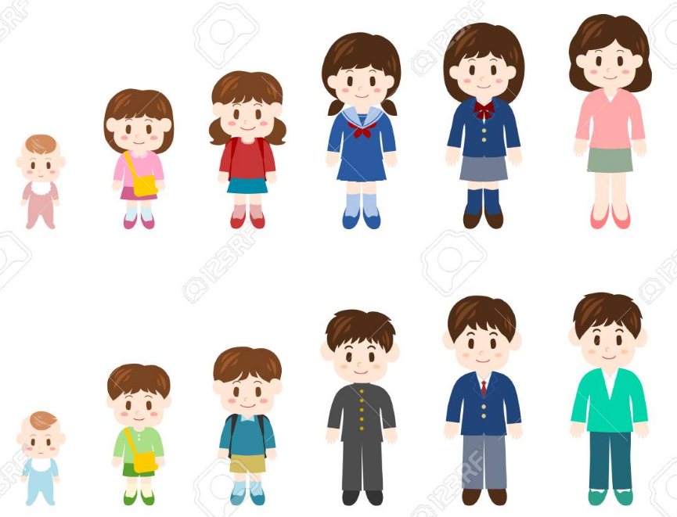
- There are some things that we are responsible for, e.g. looking after ourselves, other people and our things.
- There are several daily routines that we can follow to keep ourselves healthy and safe.
- We have a responsibility to look after our environment (e.g. our school) and other living things (e.g. people, animals and plants).
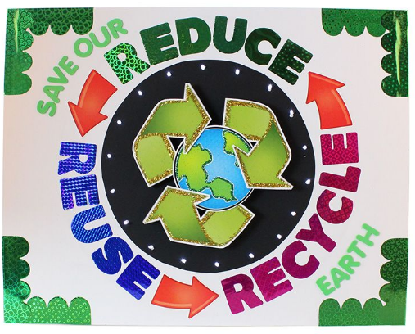

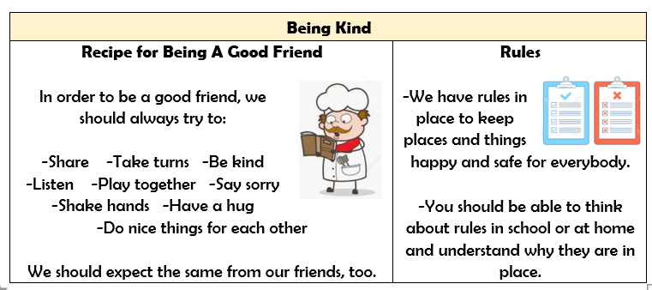

What should I be able to do at the end of the topic?
- how kind and unkind behaviour can affect others; how to be polite and courteous; how to play and work co-operatively
- the responsibilities I have in and out the classroom
- how people and animals need to be looked after and cared for
- what can harm the local and global environment; how I and others can help care for it
- how people grow and change and how people’s needs change as they grow from young to old
- how to manage change when moving to a new class/year group
 | Key Vocabulary

