Knowledge Organiser – Year 1 – PSHE/RSE
– Health and Wellbeing – Who helps to keep us safe?
– Keeping safe; people who help us
What do I already know? | 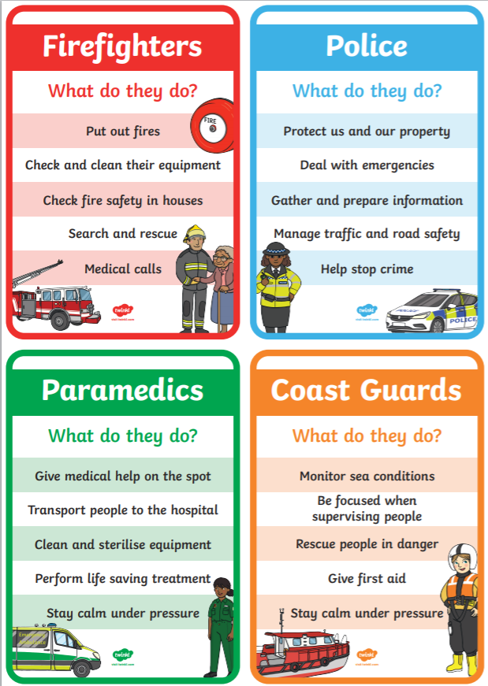  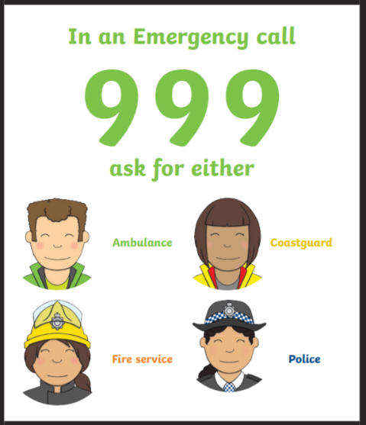  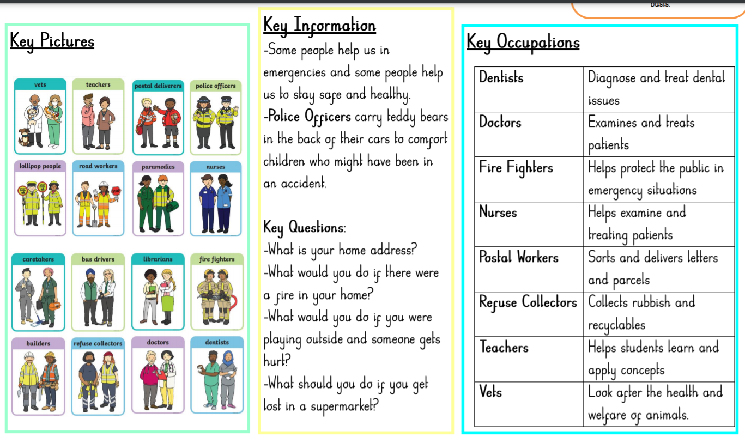
- I know there are people who love and care for me
- I can name adults who I trust and can talk to if I have a problem
- I can say the names of different jobs adults might have
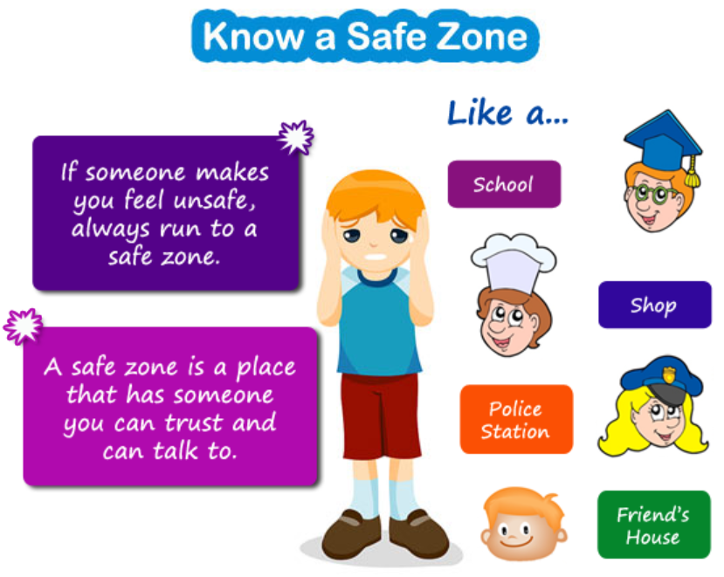

What should I be able to do at the end of the topic?
- that people have different roles in the community to help me (and others) keep safe – the jobs they do and how they help people
- who can help me in different places and situations; how to attract someone’s attention or ask for help; what to say
- how to respond safely to adults I don’t know
- what to do if I feel unsafe or worried for myself or others; and the importance of keeping on asking for support until I am heard
- how to get help if there is an accident and someone is hurt, including how to dial 999 in an emergency and what to say
Key Vocabulary

