Knowledge Organiser – Year 1 – PSHE/RSE
– Living in the Wider World –What can we do with money?
– Money; making choices; needs and wants
What do I already know? | 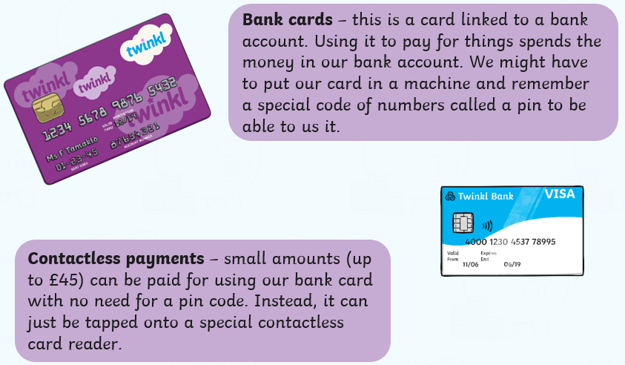  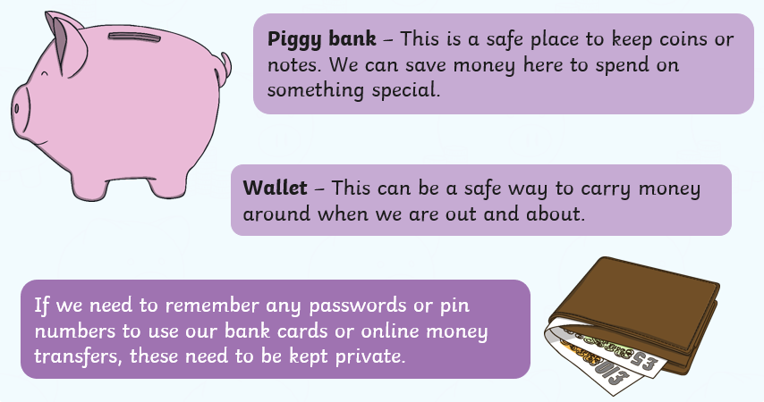  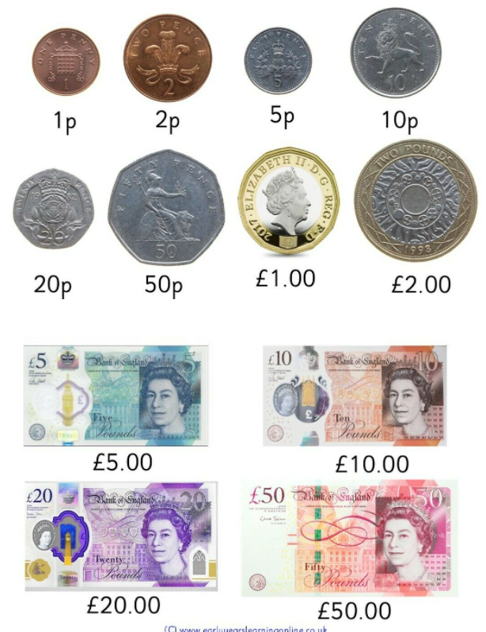
- We use money to buy things
- I can name some places to keep money
- I know that there are some things I need and some things I do not
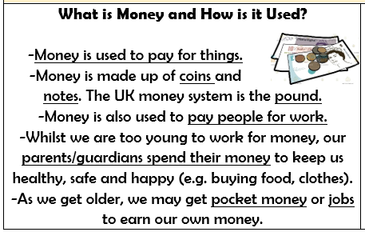

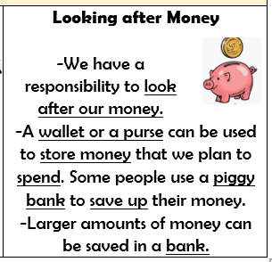
What should I be able to do at the end of the topic?
- what money is – that money comes in different forms
- how money is obtained (e.g. earned, won, borrowed, presents)
- how people make choices about what to do with money, including spending and saving
- the difference between needs and wants – that people may not always be able to have the things they want
- how to keep money safe and the different ways of doing this
Key Vocabulary

Coin Note Bank Budget

