Knowledge Organiser – Year 1 – PSHE/RSE
– Health and Wellbeing – What helps us stay healthy?
– Being healthy; hygiene; medicines; people who help us with health
What do I already know? | 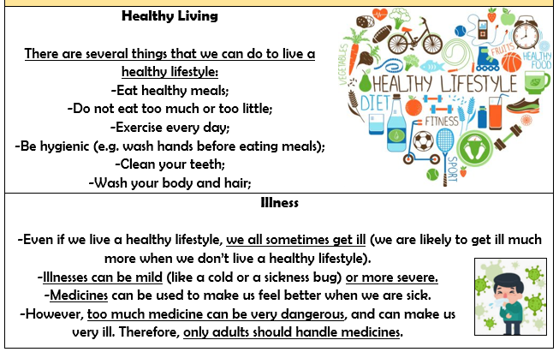  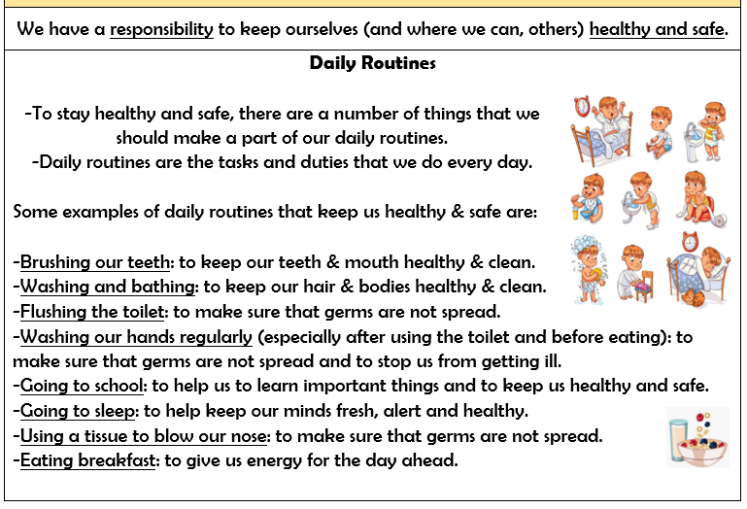  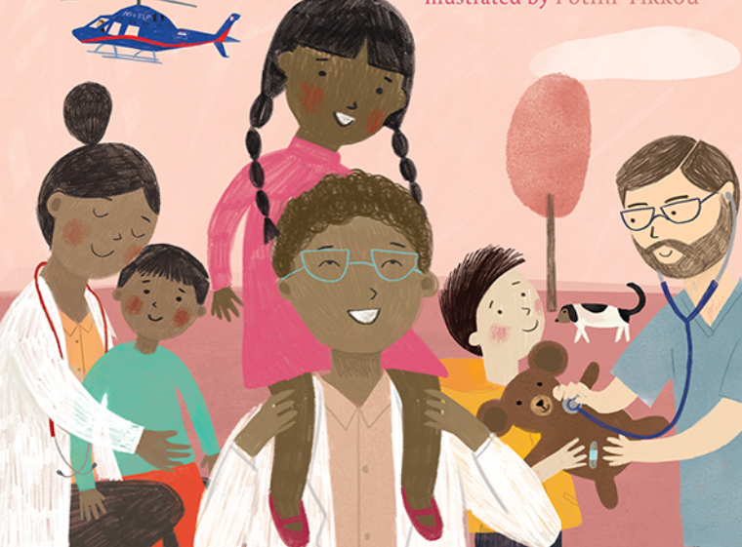
- Being healthy is about feeling good in your body and wellbeing is about feeling good in your mind.
- There are many ways that we can live a healthy lifestyle, e.g. exercise and diet.
- When we have a bad feeling about something, trusted adults can help us.
- It is important for our health and wellbeing that we get enough sleep.
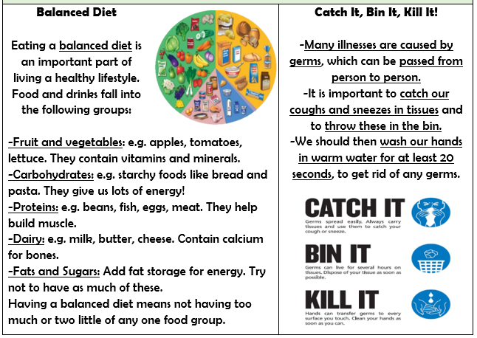

What should I be able to do at the end of the topic?
- what is being healthy means and who helps me to stay healthy (e.g. parent, dentist, doctor)
- that things people put into or onto their bodies can affect how they feel
- how medicines (including vaccinations and immunisations) can help people stay healthy and that some people need to take medicines every day to stay healthy
- why hygiene is important and how simple hygiene routines can stop germs from being passed on
- what I can do to take care of myself on a daily basis, e.g. brushing teeth and hair, hand-washing

Key Vocabulary

