Knowledge Organiser – Year 1 – PSHE/RSE
– Relationships – Who us special to us?
– Ourselves and others; people who care for us; groups we belong to; families
What do I already know? | 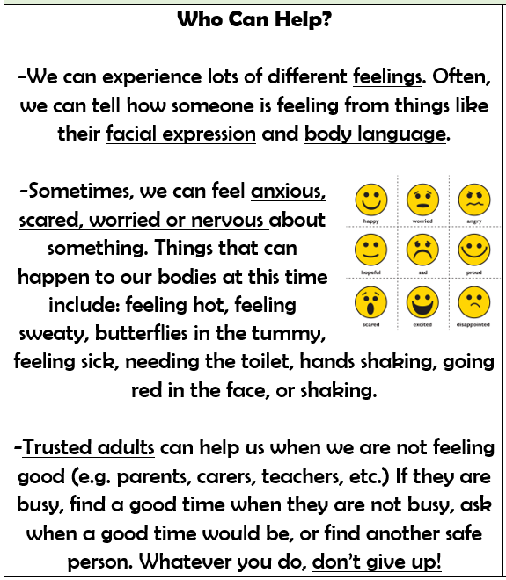  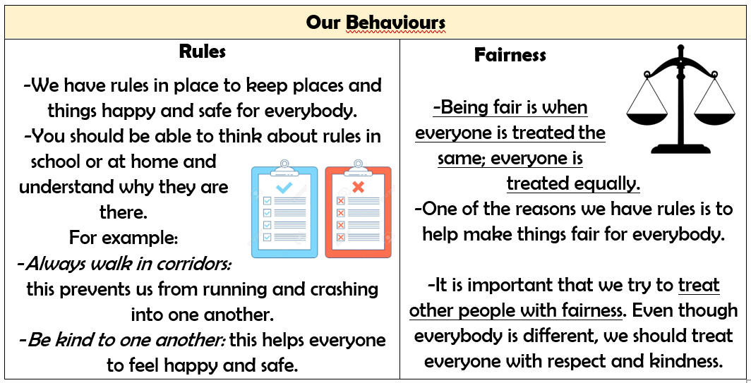
- We have special people in our lives who help and support us. There are ways that other people are similar and different to ourselves.
- We should always try to be kind to other people. It is nice to build strong relationships with other people, as we can help one another.
- We should celebrate that we are all unique and special. When thinking about similarities and differences we can consider appearance, personality, interests and talents.
- Our behaviour affects other people. We should try to follow rules and be fair to others.
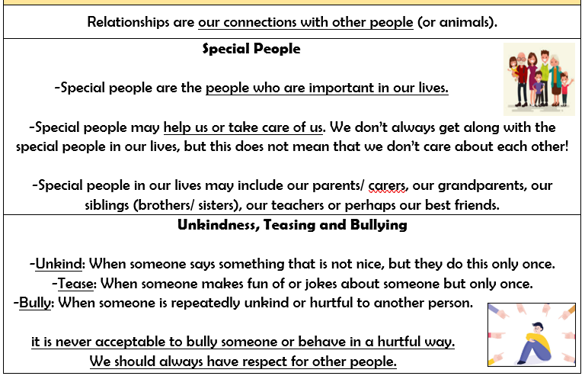

What should I be able to do at the end of the topic?
- that family is one of the groups I belong to, as well as, for example: school, friends, clubs
- about the different people in my family / those who love and care for me
- what my family members, or people that are special to me, do to make me feel loved and cared for
- how families are all different but share common features – what is the same and different about them
- about different features of family life, including what families do / enjoy together
- that it is important to tell someone (such as my teacher) if something about my family makes me feel unhappy or worried
 | Key Vocabulary

