Knowledge Organiser – Year 1 – PSHE/RSE
– Relationships – What is the same and different about us?
– Ourselves and others; similarities and differences; individuality; our bodies
What do I already know? | 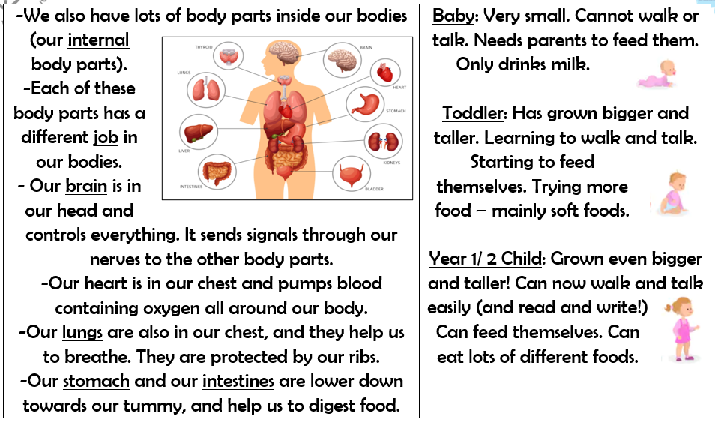  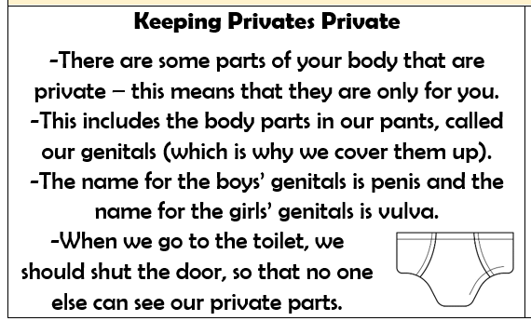  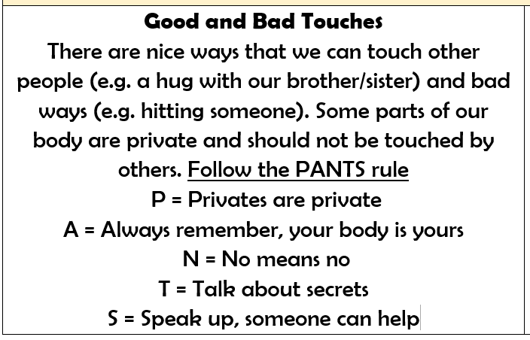
- We are all special. We have some things that make us similar to other people, and some things that make us different to other people
- There are things I like doing and things that I don’t
- There are things I am good at
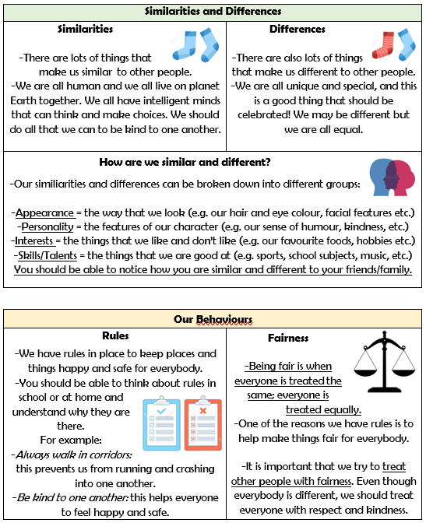

What should I be able to do at the end of the topic?
- what I like/dislike and am good at
- what makes me special and how everyone has different strengths
- how my personal features or qualities are unique to me
- how I am similar or different to others, and what we have in common
- to use the correct names for the main parts of the body, including external genitalia; and that parts of bodies covered with underwear are private
 | Key Vocabulary

