Eco  Knowledge Organiser Year 1/2
Water
Three key questions
- Where does water come from? |  |  |  | - What is the global water issue? |  |  |  |  | - How can we prevent so much water wastage?
Vocabulary |  |  |  | Issues |  |  |  |  | Solutions
Consume  Wastage  Resource  Sanitation  Water cycle  Evaporation  Condensation  Precipitation | To eat or drink  The leftovers after we have used something  A supply of something  The condition of the clean drinking water  The journey water takes as it moves from the land to the sky and back again  The process of turning from liquid into vapour  The conversion of a vapour or gas to a liquid  The product of the condensation of atmospheric water vapor that falls under gravity from cloud – rain, sleet, snow |  |  | Fresh water is a vital resource for the survival of our population. Less than 1% of the world’s water is freshwater and available for us to consume. Fresh water is limited around the world.  In the UK, we are fortunate to have drinkable water coming from our taps, but we can, and do waste clean water. There are some countries that have running water, but it is not recommended for drinking, however bottled water is available.  There are many countries where they have no access to any clean water and people are left drinking dirty water from the nearby stream. Drinking this water leads to disease and illness. |  |  |  |  | There are many ways we can save water.  - Shower instead of bathing.  - Turn the taps off when they are not in use e.g. when brushing teeth.  - Collect and use rainwater to water plants  - Fix leaky pipes and taps.  - In school, we have taps that turn off automatically and water butts to collect rainwater  Find out more at https://www.waterwise.org.uk/  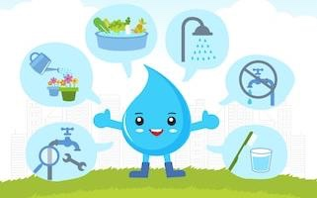  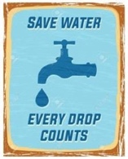  World water day 22nd March 2021 https://www.worldwaterday.org/
Curriculum links
English |  |  | Maths |  |  | Geography |  | Design and technology |  | Science
Make a poster about saving water  Label the water cycle |  | Use different measuring equipment to explore capacity |  |  | Find out about the water cycle  Explore the flow of water over different surfaces in the school grounds |  | Design and make a water cycle  Design a water wheel |  |  | Investigate the different states of matter of water  Investigate where water can be found in the natural environment  Explore why plants and animals need water
Whole school initiatives
*Auto off taps in all bathrooms * Water butts for collecting and re-using rainwater *Education about the water cycle and water pollution *Re-useable cups/bottle at snack and lunchtime

