Eco  Knowledge Organiser EYFS N/R
Water
Three key questions
- Where does water come from? |  |  |  | - What is the global water issue? |  |  |  |  |  |  | - How can we prevent so much water wastage?
Vocabulary |  |  |  | Issues |  |  |  |  |  |  | Solutions
Consume  Wastage  Resource  Sanitation | To eat or drink  The leftovers after we have used something  A supply of something  The condition of the clean drinking water |  |  | Fresh water is a vital resource for the survival of our population. Less than 1% of the world’s water is freshwater and available for us to consume. Fresh water is a limited resource around the world.  In the UK, we are fortunate to have drinkable water coming from our taps, but we can, and do waste clean water. There are some countries that have running water, but it is not recommended for drinking, however bottled water is available.  There are many countries where they have no access to any clean water and people are left drinking dirty water from the nearby stream. Drinking this water leads to disease and illness. |  |  |  |  |  |  | 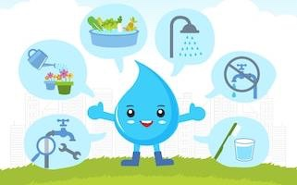  There are many ways we can save water.  - Shower instead of bathing.  - Turn the taps off when they are not in use e.g. when brushing teeth.  - Collect and use rainwater to water plants  - Fix leaky pipes and taps.  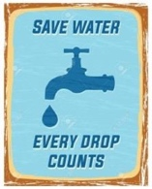  - In school, we have taps that turn off automatically and water butts to collect rainwater  Find out more at https://www.waterwise.org.uk/  World water day 22nd March 2021 https://www.worldwaterday.org/
Curriculum links
PSED |  | Communication and language |  |  |  | Physical |  | Literacy | Mathematics |  |  | Understanding the world | Expressive art and design
Making relationships  Self-confidence and self-awareness  Managing feelings and behaviour |  |  | Listening and attention  Understanding  Speaking |  |  | Moving and handling  Health and self-care | Reading  Writing |  | Numbers  Shape, space and measure |  |  | People and communities  The world  Technology | Exploring and using media and materials  Being Imaginative
Chracteristics of effective learning
Playing and exploring – engagement |  |  |  |  | Active learning – motivation |  |  |  |  | Creating and thinking critically – thinking
Whole school initiatives
Auto off taps in all bathrooms Water butts for collecting and re-using rainwater Education about the water cycle and water pollution

