Eco  Knowledge Organiser Year 5/6
School Grounds
Three key questions
1) Why is important to have good school grounds? |  |  | 2) How can we look after our school grounds? |  |  | 3) How environmentally friendly are our school grounds?
Vocabulary |  |  | Issues |  |  | Solutions
Environment  Inhabit  School grounds  Allotment  Boundary  Orientation | The world around us  Where they live  The place/area where the school is including the playground and wildlife garden.  A plot of land for growing plants, vegetables, flowers, herbs and fruit.  A real or imaginary line that indicates the farthest limit of an area.  The act of finding someone or something in a location or position relative to the points of the compass |  | Children today spend less than half the time playing outdoors that their parents did and are less likely to spend time outdoors at school.  They are growing up in an increasingly indoor and virtual world, ever more divorced from the real world around them.  This has a significant impact on their physical health, emotional wellbeing, social competence and their connection with the natural world and their local communities.  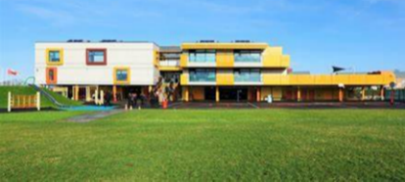  One of the best places for children to enjoy the outdoors, learn about the natural world and take vigorous exercise on a regular basis is in the school grounds. |  |  | We can look after the plants and animals that inhabit our school grounds.  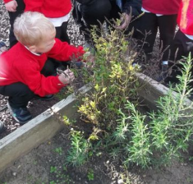  We use the correct recycle bins.  We can make our playground look friendly.  We can treat our equipment with respect.  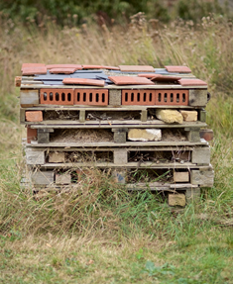  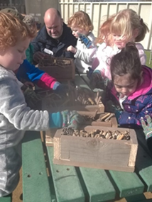  We can work with others to develop our school grounds
Curriculum links
English |  | Maths |  | Art | Science |  | Geography
Find appropriate places in the school grounds to read, improvise, debate and present  Write instructions for making the school grounds more environmentally friendly  Write a persuasive letter to the Headteacher asking for funds to improve the school ground, or to begin a school grounds project e.g., building a hedgehog home |  | Create planters in the school grounds with a focus on perimeter, area and volume.  Present data using statistics from before and after an action and consider the impact of their actions.  Construct pie-charts and line graphs from observations in the school grounds |  | Investigate the different natural materials you can use to create some art work.  Make observational drawings of the school grounds  Research artists and designers on the school and it’s grounds  Create large scale art from your research  Using clay recreate some of the natural features from the school grounds | Take measurements, using a range of scientific equipment, taking repeat  readings when appropriate  Use test results to make predictions to set up further comparative and fair tests  Use the playground to create models showing the movement of the Sun, Earth and Moon  Use the playground to explore how their pulse rate, changes during and after exercise. |  |  | use fieldwork to observe, measure, record and present the human and physical features  Draw a grid on the playground – give instructions using the eight points of the compass for direction  Use OS maps, keys and symbols to develop orienteering skills.  Use the playground to draw maps of the local community, UK and the world.
Whole school initiatives
* School garden/wildlife area * Bug hotel/bird boxes/bird watching *Recycle bins *Pirate ship and Adventure trail
* Allotment *Swimming pool *Involvement of the whole school in the above * Work with Essex Wildlife Trust

