Eco  Knowledge Organiser Year 3/4
School Grounds
Three key questions
1) Why is important to have good school grounds? |  |  | 2) How can we look after our school grounds? |  |  | 3) How environmentally friendly are our school grounds?
Vocabulary |  |  | Issues |  |  | Solutions
Environment  Inhabit  School grounds  Allotment | The world around us  Where they live  The place/area where the school  is including the playground and wildlife garden.  A plot of land for growing plants, vegetables, flowers, herbs and fruit. |  | Children today spend less than half the time playing outdoors that their parents did and are less likely to spend time outdoors at school.  They are growing up in an increasingly indoor and virtual world, ever more divorced from the real world around them.  This has a significant impact on their physical health, emotional wellbeing, social competence and their connection with the natural world and their local communities.  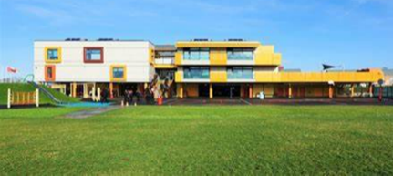  One of the best places for children to enjoy the outdoors, learn about the natural world and take vigorous exercise on a regular basis is in the school grounds. |  |  | We can look after the plants and animals that inhabit our school grounds.  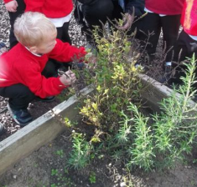  We use the correct recycle bins.  We can make our playground look friendly.  We can treat our equipment with respect.  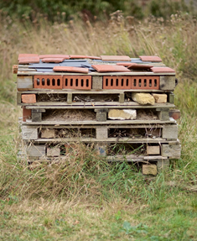  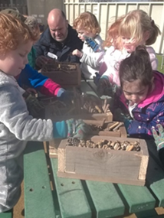  We can work with others to develop our school grounds
Curriculum links
English |  | Maths |  | Art | Science |  | Geography
Write a story about an animal living, or plant growing within your school grounds.  Use the school grounds to create a spelling hunt or find the matching word  Find appropriate places in the school grounds to read, improvise, debate and present |  | Design a new eco-school playground, plot the playground on graph paper and calculating the area and perimeter of your different eco-features  Use the school grounds to practice the times tables  Match multiplication and division facts with the answers written with chalk on the ground |  | Investigate the different natural materials you can use to create some art work.  Make observational drawings of the school grounds  Research artists and designers on the school and it’s grounds | Identify the plants within school  grounds, how does this vary across  the seasons?  Pupils identify the producers, predators  and prey in the micro-habitats in the  playground or local environment.  Collect and group rocks from the school grounds |  |  | use fieldwork to observe, measure, record and present the human and physical features  Draw a grid on the playground – give instructions using the eight points of the compass for direction
Whole school initiatives
* School garden/wildlife area * Bug hotel/bird boxes/bird watching *Recycle bins *Pirate ship and Adventure trail
* Allotment *Swimming pool *Involvement of the whole school in the above * Work with Essex Wildlife Trust

