Eco  Knowledge Organiser Year 1/2
School Grounds
Three key questions
1) Why is important to have good school grounds? |  |  | 2) How can we look after our school grounds? |  |  | 3) How environmentally friendly are our school grounds?
Vocabulary |  |  | Issues |  |  | Solutions
Environment  Inhabit  School grounds  Allotment | The world around us  Where they live  The place/area where the school  is including the playground and wildlife garden.  A plot of land for growing plants, vegetables, flowers, herbs and fruit. |  | Children today spend less than half the time playing outdoors that their parents did and are less likely to spend time outdoors at school.  They are growing up in an increasingly indoor and virtual world, ever more divorced from the real world around them.  This has a significant impact on their physical health, emotional wellbeing, social competence and their connection with the natural world and their local communities.  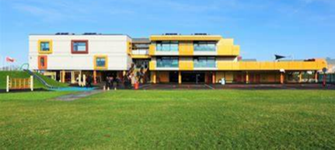  One of the best places for children to enjoy the outdoors, learn about the natural world and take vigorous exercise on a regular basis is in the school grounds. |  |  | We can look after the plants and animals that inhabit our school grounds.  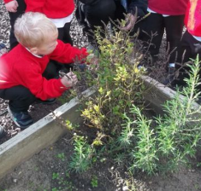  We use the correct recycle bins.  We can make our playground look friendly.  We can treat our equipment with respect.  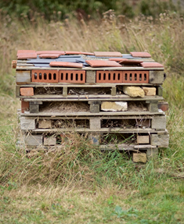  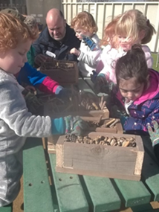  We can work with others to develop our school grounds
Curriculum links
English |  | Maths |  | Art | Science |  | Geography
Write a story about an animal living, or plant growing within your school grounds.  Use the school grounds to create a spelling hunt or find the matching word  Join in with discussions, presentations, performances, role play, improvisations and debates |  | compare/measure objects in outdoor area  Count in 2s, 3s 5s,10s; Identify, represent, estimate, compare and order numbers using natural/found objects  Use the local environment to recognise and name 2d & 3d shapes; Describe position, direction and movement |  | Investigate the different natural materials you can use to create some art work.  Make observational drawings  Research artists and designers on the school and it’s grounds | Photograph a tree throughout the year and identify changes in the photos, describe its basic structure and how the seasons have an effect.  Go on a materials hunt. Look at the use of materials in outdoor area. Identify and name everyday materials. Describe, compare and group/sort them.  observe and describe how seeds and bulbs grow into mature plants. |  |  | use fieldwork to observe, measure, record and present the human and physical features  Identify seasonal and daily weather patterns.  Create a map of the school grounds
Whole school initiatives
* School garden/wildlife area * Bug hotel/bird boxes/bird watching *Recycle bins *Class litter pickers *Pirate ship and Adventure trail
* Allotment *Swimming pool *Involvement of the whole school in the above * Work with Essex Wildlife Trust

