Eco  Knowledge Organiser Year 1/2
Healthy Lifestyles
Three key questions
1) Why is it important to live healthily? |  |  |  | 2) What affect can living healthily have on our bodies? |  |  | 3) How can we care for our mental well-being?
Vocabulary |  |  |  | Issues |  |  | Solutions
Healthy  Well-being  Obese  Decay  Physical  Exercise  Nutrition | In good physical and mental condition.  The state of being healthy, happy and comfortable.  Grossly fat/overweight.  To rot away.  Related to the body, things you can do with your body  Activity requiring physical effort, carried out to sustain or improve health and fitness  The process of providing or obtaining the food necessary for health and growth |  |  | Many children and adults suffer from poor mental and physical wellbeing and this is due to lack of healthy living.  We think that the mind and body are separate. But what you do  with your body can have a powerful effect on your mental wellbeing. Mental wellbeing means feeling good – both about yourself and about the world around you. It means being able to get on with life in the way you want.  Evidence shows there is a link between being physically active and  good mental well-being.  34% of children leave primary school overweight!  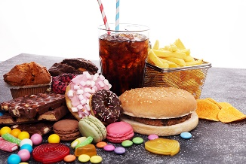  How does unhealthy living affect us?  - Being overweight or obese;  - Tooth decay;  - Future serious medical  problems. |  |  | If we lead a healthy life by eating a balanced diet and taking part in daily exercise, we will not only have a healthy body and avoid many possible serious health problems but we will also improve our mental well-being too!  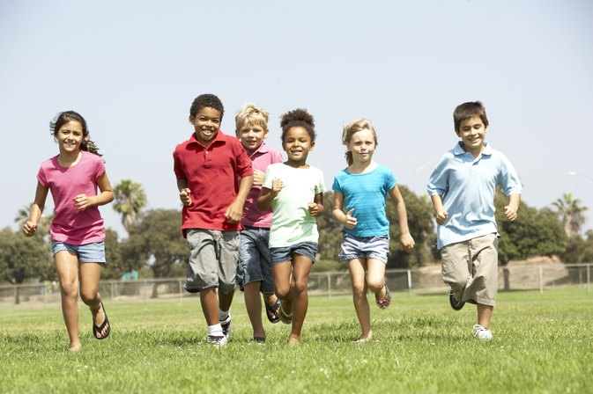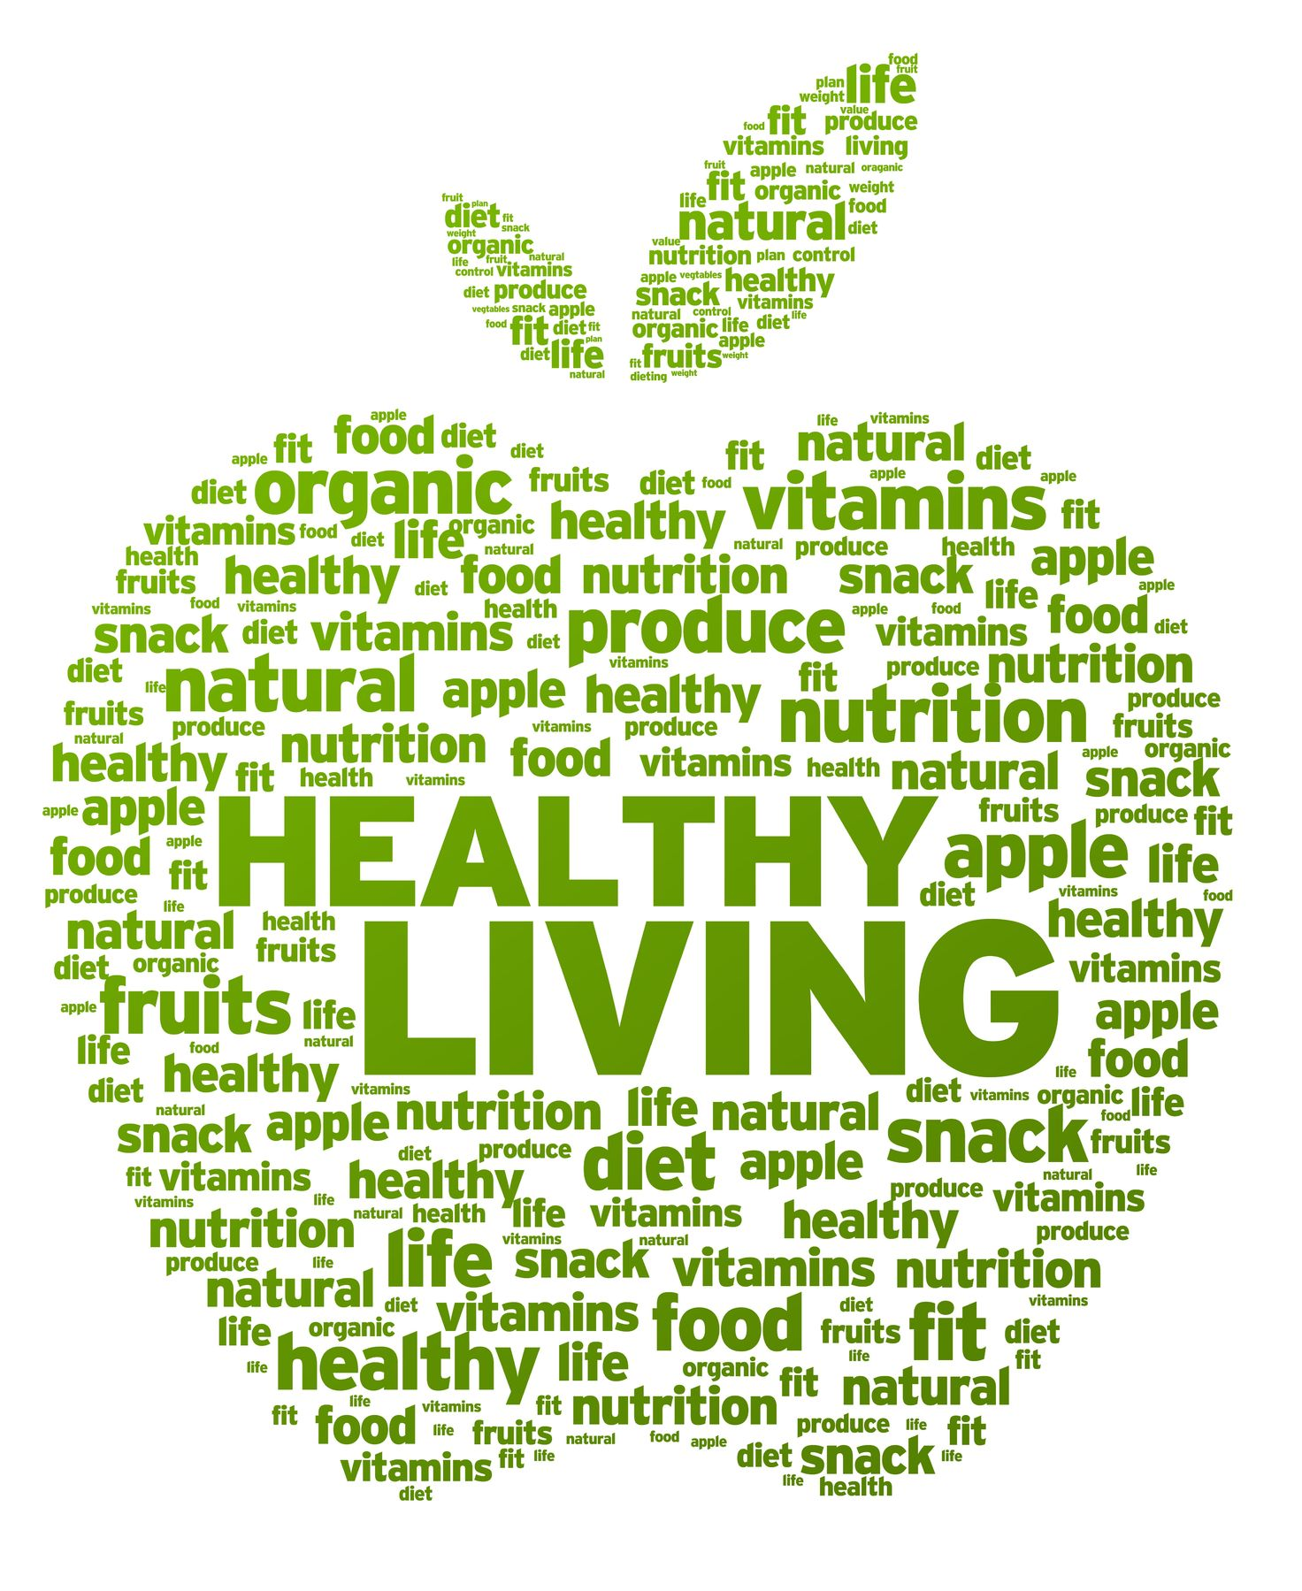
Curriculum links
English |  |  | Maths |  | PE | Design and Technology/Art and Design |  | Science
Write a recipe for a healthy meal  Discuss how school encourages healthy living  Create and advertise a healthy snack or drink |  | Record the items in the packed lunches  in school.  Create a Venn diagram showing healthy and unhealthy foods  Find out about different foods. |  |  | Create a fun obstacle course  Demonstrate exercises that would help  and support physical well-being. | Follow a recipe to make a healthy meal/snack  Design a poster to promote your favourite exercise  Use different foods to create art |  | Learn about the different food groups and their importance within a balanced diet  Investigate and learn about the human skeleton.  Describe the simple functions of the basic parts of the digestive system in humans
Whole school initiatives
*Healthy school dinners *Promotion of healthy lunchboxes *Daily Mile *Outdoor learning *Water, milk and fruit for snack *Cooking lessons *Healthy Tuck shop *Communication with parents and community to promote healthy lifestyle. *Brain breaks in lessons

