Eco 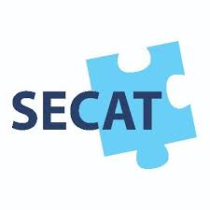 Knowledge Organiser EYFS N/R
Healthy Lifestyles
Three key questions
1) Why is it important to live healthily? |  |  |  |  | 2) What affect can living healthily have on our bodies? |  |  |  |  | 3) How can we care for our mental well-being?
Vocabulary |  |  |  |  | Issues |  |  |  |  | Solutions
Healthy  Well-being  Obese  Decay  Physical  Exercise  Nutrition | In good physical and mental condition.  The state of being healthy, happy and comfortable.  Grossly fat/overweight.  To rot away.  Related to the body, things you can do with your body  Activity requiring physical effort, carried out to sustain or improve health and fitness  The process of providing or obtaining the food necessary for health and growth |  |  |  | Many children and adults suffer from poor mental and physical wellbeing and this is due to lack of healthy living.  We think that the mind and body are separate. But what you do  with your body can have a powerful effect on your mental wellbeing. Mental wellbeing means feeling good – both about yourself and about the world around you. It means being able to get on with life in the way you want.  Evidence shows there is a link between being physically active and  good mental well-being.  34% of children leave primary school overweight!  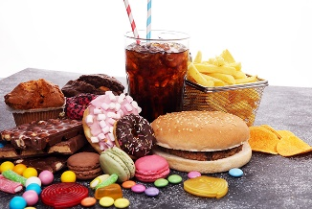  How does unhealthy living affect us?  - Being overweight or obese;  - Tooth decay;  - Future serious medical  problems. |  |  |  |  | If we lead a healthy life by eating a balanced diet and taking part in daily exercise, we will not only have a healthy body and avoid many possible serious health problems but we will also improve our mental well-being too!  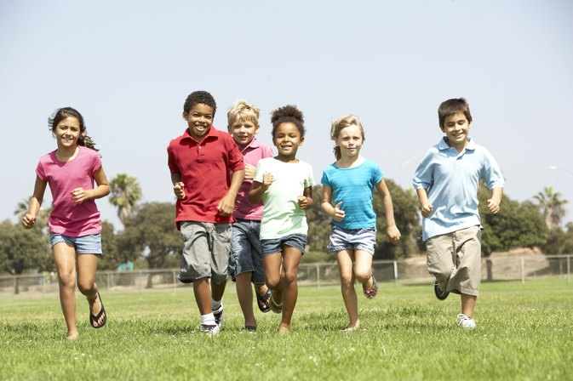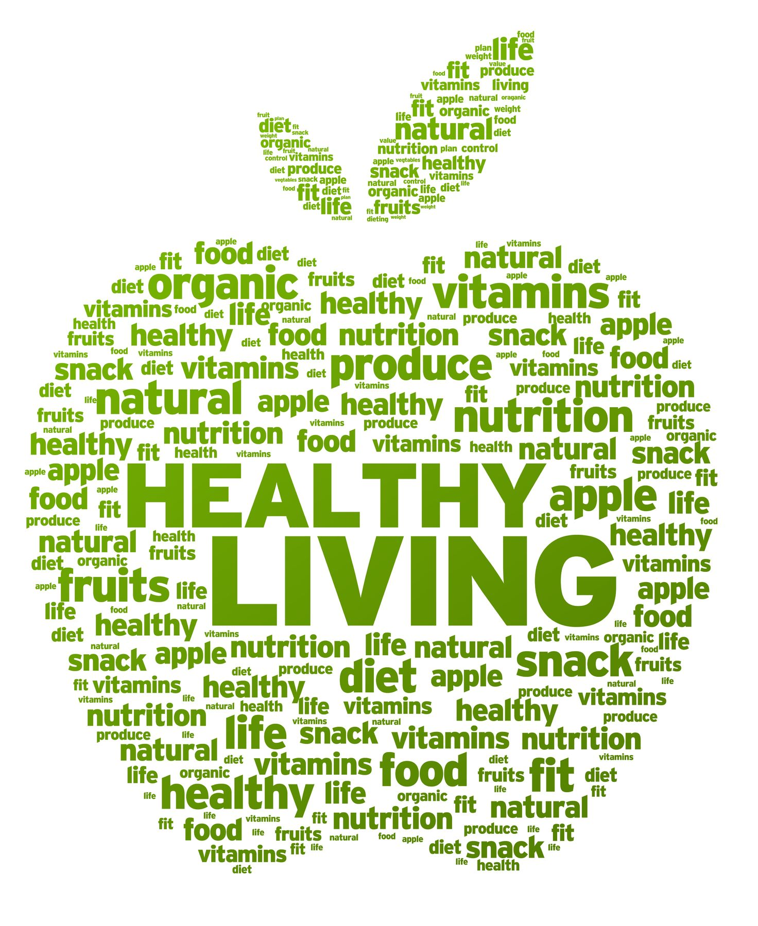
Curriculum links
PSED |  | Communication and language |  |  | Physical |  | Literacy | Mathematics |  |  | Understanding the world | Expressive art and design
Making relationships  Self-confidence and self-awareness  Managing feelings and behaviour |  |  | Listening and attention  Understanding  Speaking |  | Moving and handling  Health and self-care | Reading  Writing |  | Numbers  Shape, space and measure |  |  | People and communities  The world  Technology | Exploring and using media and materials  Being Imaginative
Chracteristics of effective learning
Playing and exploring – engagement |  |  |  | Active learning – motivation |  |  |  |  | Creating and thinking critically – thinking
Whole school initiatives
*Healthy school dinners *Promotion of healthy lunchboxes *Daily Mile *Outdoor learning *Water, milk and fruit for snack *Cooking lessons *Healthy Tuck shop *Communication with parents and community to promote healthy lifestyle. *Brain breaks in lessons

