Eco  Knowledge Organiser EYFS N/R
Energy
Three key questions
1) Where does the energy to power our home or school come from? |  |  |  | 2) What can we do to help reduce the need for so much energy? |  |  |  |  | 3) Is the source of energy sustainable?
Vocabulary |  |  |  | Issues |  |  |  |  | Solutions
Renewable  Energy  Natural  Sustainable | Not depleted with use.  Still there for use. Power.  Not made by man.  We can maintain it, keep it going. |  |  | A lot of the energy we use to power the world around us is sourced from non-renewable sources. Non-renewable energy sources don’t replenish, and are formed when prehistoric plants and animals died and were gradually buried by layers of soil rock. The kind of fuel that was created varied depending on the conditions, like what kind of organic material (from plants or animals), how long it was buried, at what temperature and under what pressure. Types of non-renewable energy are natural gas, coal and oil. As a world, we should be using more renewable energy sources. Renewable energy is collected from renewable resources. A source of energy is considered renewable if it comes from natural sources or processes that are constantly replenished. Examples are solar (from the sun), wind, water, geothermal (from the earth) and biomass (from organic materials).  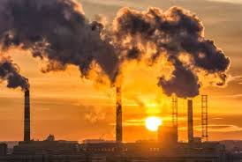  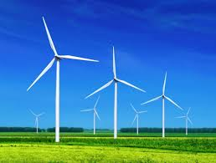 |  |  |  |  | Until this problem is resolved globally, what can we do to reduce our energy use?  - Turn off the tap when not in use  - Turn off electrical  - Walk or ride to school  - Wear a jumper instead of putting on or turning up heating  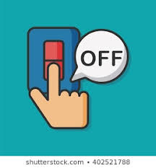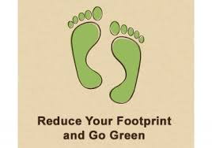
Curriculum links
PSED |  | Communication and language |  | Physical |  |  | Literacy | Mathematics |  |  | Understanding the world | Expressive art and design
Making relationships  Self-confidence and self-awareness  Managing feelings and behaviour |  |  | Listening and attention  Understanding  Speaking | Moving and handling  Health and self-care |  | Reading  Writing |  | Numbers  Shape, space and measure |  |  | People and communities  The world  Technology | Exploring and using media and materials  Being Imaginative
Chracteristics of effective learning
Playing and exploring – engagement |  |  |  |  | Active learning – motivation |  |  |  |  | Creating and thinking critically – thinking
Whole school initiatives
Encourage walking/cycling/scooting to school Take part in ‘switch off fortnight’ Education/posters to encourage turning off lights Education/posters to encourage recycling

