Hinguar Primary School and Nursery - SECAT
Knowledge Organiser
History | Year Four | Spring Term | Topic: Making Waves  (Significant names in Scientific History)
Prior Knowledge |  | Application of Knowledge
- I can place significant events in early history of man on a timeline and locate the Egyptian, Mayan and Indus Civilisations on a map  - I know the achievements of early man from the Bronze age to the Iron Age  - I have learnt about how different civilisations developed at different speeds |  | - Research the work of Alexander Graham Bell  - Understand the difficulties Garret Morgan faced because of his race and the attitudes of society at the time  - Place both Alexander Graham Bell and Garrett Morgan on a timeline and compare their lives and experiences as scientists and inventors
What will I know by the end of this topic? |  | Key Vocabulary
- When and where was Alexander Graham Bell born?  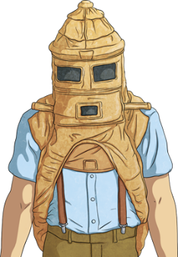  - When and where was Garrett Morgan born?  - What were their childhoods like?  - What role did they play in the world of science?  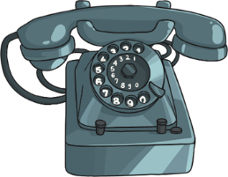  - What impact did they have on the rest of the world? |  | Alexander Graham Bell | a Scottish scientist and inventor.
 |  | Garrett Morgan | was an American inventor, famous for inventing the first modern gas mask and the first three-signal traffic lights.
 |  | Electricity
 |  | Prejudice
 |  | Segregation


