Hinguar Primary School and Nursery - SECAT
Knowledge Organiser
History | Year Four | Autumn Term | Topic: Indus Civilisation
Prior Knowledge |  | Application of Knowledge
- I can place significant events on a timeline  - I know the achievements of early man from the Stone age up to the Iron Age  - I have learnt about early man communities |  | - identify key features, aspects and events of the time studied;  - gather more detail from sources such as maps to build up a clearer picture of the past;  - use and understand appropriate historical vocabulary to communicate information such as ruled, reigned, empire, invasion, conquer, kingdoms;
What will I know by the end of this topic? |  | Key Vocabulary
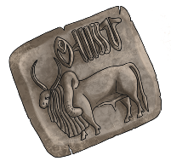  - Where would you place the Indus Valley civilisation on a timeline?  - Where was the Indus Valley civilisation located?  - What were the achievements of the Indus Valley Civilisation?  - Can children compare Indus Valley civilisation settlements with Bronze Age British settlements?  - What were the main features of an Indus Valley civilisation settlement?  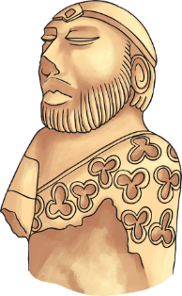  - What might the settlements have looked like?  - Who did the Indus Valley civilisation trade with?  - What were typical crafts of the Indus Valley civilisation?  - What were the Indus Valley civilisation seals and what were they used for?  - What was special about their system of measure compared to other civilisations at the time?  - Can you compare the Indus Valley civilisation with Bronze Age Britain?  - What theories are there for why the Indus Valley civilisation declined? |  | soapstone | soapstone A soft rock that can be carved easily.
 |  | seal | A small stamp with an individual design, used for pressing into a soft material like  clay to show who made or sent an item.
 |  | ‘Seal’ | ‘Seal’ can also refer to the stamped clay.
 |  | goods | Items for sale or things that have been bought.
 |  | loincloth | A piece of cloth wrapped around the  hips, similar to a skirt but generally  worn by men.
 |  | citadel | An area on a mound of land, higher than the rest of a city. Sometimes citadels have walls to separate them from the rest of the city.
 |  | bitumen tar | A semi-solid, sticky, black substance.
 |  | Charles Masson | Charles Masson had been in the  British army in India. Other people  who contributed to the discovery and  excavations of Harappa and Mohenjo Daro include Sir John Marshall, Rai  Bahadur Daya Ram Sahni, RD Banerji  and Sir Alexander Cunningham.
 |  | 

