 | Hinguar Primary School and Nursery - SECAT
 | Knowledge Organiser
History |  | Year Three | Spring Term |  | Topic: Ancient Egyptians
Prior Knowledge |  |  | Application of Knowledge
- Used the language of time e.g. decade, century, millennium  - Made simple observations about sources  - Asked questions based on sources, core knowledge and comparisons to other periods of history  - Use a range of sources including documents, artefacts, databases and historical buildings  - Use primary sources to find information |  |  | - Place significant events from the Ancient Egyptian civilisation on a timeline  - Use vocabulary such as BC and AD to describe when events happened and when significant Egyptians lived  - Name key facts relating to significant individuals, events, periods of time and civilisations and know their impact.  - Use a range of sources including photographs and artefact replicas to answer and create historical questions  - How to use inference to interpret sources.  - Begin to see there are different accounts of history.
What will I know by the end of this topic? |  |  | Key Vocabulary
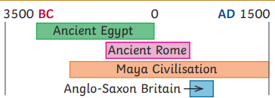  - What was life like in Ancient Egypt?  - Why was the River Nile important to daily life?  - How can we find out about life in Ancient Egypt?  - What were the pyramids built for?  - Who were the Pharaohs?  - What religious beliefs did the Ancient Egyptians have?  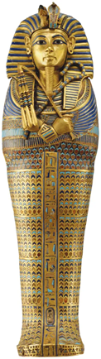  - Who were the Egyptian gods?  - Who was Tutankhamun?  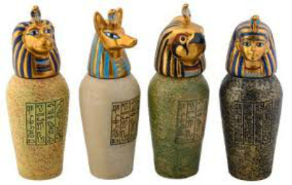  - Why was Howard Carter’s discovery so important? |  |  | Artefact | an object made by a human being, typically one of cultural or historical interest
 |  |  | Ancient | belonging to the very distant past and no longer in existence.
 |  |  | Pharaoh | The monarchs of Ancient Egypt, both male and female.
 |  |  | Tomb | A large vault, typically an underground one for the Egyptians inside a pyramid, for burying the dead.
 |  |  | Pyramid | a structure whose outer surfaces are triangular and converge to a single step at the top.
 |  |  | hieroglyphics | A system of writing that used pictures and symbols (hieroglyphs) instead of letters.’
 |  |  | River Nile | The Nile is a major north-flowing river in North-Eastern Africa. It played a significant
 |  |  | Century | A period of 100 years
 |  |  | BC | Used to show that a date is before the year 0. This is counted backwards, so 200 BC is before 100 BC.
 |  |  | AD | Used to show that a date is after the year 0.
 |  |  | irrigation | A system of canals or channels Egyptians dug to supply water to grow crops over a larger area than the water would reach naturally.
 |  |  | silt | Fine particles of soil, clay or sand carried and
 |  |  | Afterlife | After death, the Egyptians believed that the afterlife was a 'Field of Reeds' where people would live forever without sickness or death.
 |  |  | 

