Hinguar Primary School and Nursery - SECAT
Knowledge Organiser
History | Year 2 | Spring Term |  | Topic: Global Explorers
Prior Knowledge |  | Application of Knowledge
- I know that we live in the 21st Century  - I know about other famous people like David Attenborough and Grace Darling who have helped to change the world  - I can sequence events on a simple timeline |  | - Discuss the role Nelson Mandela played in the human rights movement  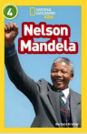  - Understand that people used to behave differently in the past  - Write about the good things that Nelson Mandela achieved
What will I know by the end of this topic? |  | Key Vocabulary
  - Who was Nelson Mandela?  - When and where was he born?  - Where did he live?  - What did he do for his country?  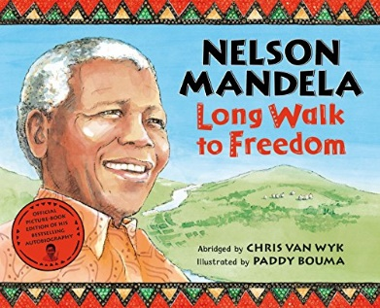  - Is he still alive?  - How did he help the world? |  | Government | A group of people who make the laws for their country
 |  | Democracy | Where people get the chance to vote for the people in their government
 |  | President | The head of a government
 |  | significant | Important and worth knowing about.
 |  | South Africa | A country in Africa where Nelson Mandela lived
 |  | Apartheid | A law that made black people be treated differently to white people
 |  | confinement | when a person is kept somewhere, usually by force
 |  | Afrikaans | A language based on German which people speak in South Africa
 |  | settlers | People who move from the country they are born in and settle in a new country
 |  | 

