Hinguar Primary School and Nursery - SECAT
Knowledge Organiser
History | Year 1 | Spring Term | Topic: The Great Outdoors
Prior Knowledge |  | Application of Knowledge
- I know some places and some living things are different to each other and some are the same  - I can talk about the features of my own immediate environment and how it might be different from another |  | 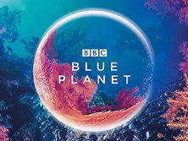  - Describe the part David Attenborough has played in helping our planet  - Create a fact file about David Attenborough  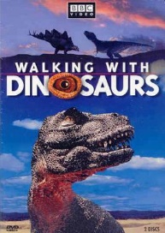  - List important documentaries he has made that have had an impact all over the world
What will I know by the end of this topic? |  | Key Vocabulary
- Who is David Attenborough and why is he so significant to our world?  - When and how did he become famous?  - Does he still help our planet? If so, how?  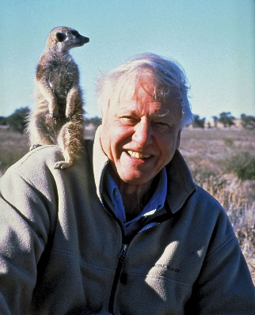 |  | Naturalist | A person who studies nature
 |  | 20th century | The 20th century was 1900-1999.
 |  | Career | job
 |  | Nature | Products of the earth – plants and animals
 |  | Documentary | Using pictures, videos and interviews to provide a factual report
 |  | Wildlife | Wild animals
 |  | Habitat | An animal’s home – where they live

