Hinguar Primary School and Nursery - SECAT
Knowledge Organiser
History | Year 1 | Autumn Term |  | Topic: Terrific Toys
Prior Knowledge |  | Application of Knowledge
- I know that the past is something that has already happened  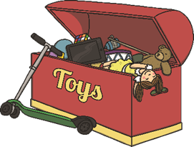  - I know that I had family members who were alive in the past |  | - describe memories and changes that have happened in their own lives;  - recognise some similarities and differences between the past and the present;  - observe and use pictures, photographs and artefacts to find out about the past;
What will I know by the end of this topic? |  | Key Vocabulary
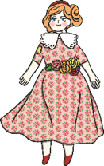  - How long have toys existed?  - What do we know about toys today?  - What were toys made of during the Victorian age?  - What toys did Victorian children play with?  - What is the difference between Victorian and modern toys?  - What are modern toys made of?  - How are modern toys different?  - How have toys changed over time?  - Which words mean that time has passed?  - What can we use to find out about the past?  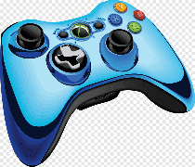  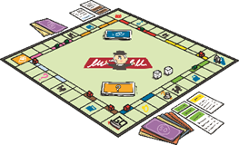 |  | Victorian | The time of Queen Victoria’s reign. 1837-1901.
 |  | 20th century | The 20th century was 1900-1999.
 |  | 21st century | We are in the 21st century. It started in the year 2000 and will end in 2099.
 |  | wooden toys | Lots of toys were made of wood. Boats, train sets and cup and ball were all made of wood. Some toys are still made of wood.
 |  | paper toys | Some toys, like paper windmills, were made out of paper.
 |  | metal toys | Toy soldiers and some spinning tops were made out of metal.
 |  | plastic toys | Most modern toys are made of plastic. Toy soldiers, dolls and ride-on cars are usually made of plastic.

