Hinguar Primary School and Nursery - SECAT
Knowledge Organiser
History | Year 1 | Summer Term |  | Topic: Beside the Seaside
Prior Knowledge |  | Application of Knowledge
- I know about changes that have happened since I was born  - I can talk about important people from the past  - I know that things happened a long time ago before I was born  - I know one person can make a difference |  | - Talk about why lifeboats are important where I live in Southend  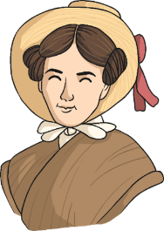  - Write about how the RNLI has changed in the last 100 years  - Explain why Grace Darling became a national heroine.  - Sequence the events of Grace Darling’s rescue of the passengers of the Forfarshire.
What will I know by the end of this topic? |  | Key Vocabulary
- What are the features and landmarks of the seaside?  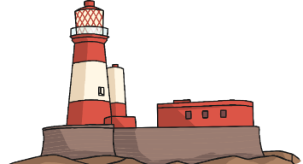  - What is a lighthouse and how do they work?  - What is the role of a lifeguard past and present?  - Who was Grace Darling and why is she famous?  - What was life by the sea like when Grace Darling was a child compared to now in the 21st Century?  - How is a trip to the beach now different to Victorian times?  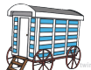  - What were bathing  machines used for in  Victorian times? |  | lighthouse | a tower with a flashing light for guiding ships and warning them of dangers in the water
 |  | Wreck | the destruction of a ship at sea; a shipwreck.
 |  | Victorian | the period between approximately 1820 and 1914
 |  | rescue | to free or save.
 |  | lifeboat | a boat made for quick rescue of people. It can be carried on a larger boat, or it can be used from shore.
 |  | cliff | a high, steep face of rock or earth.
 |  | pier | a long, flat structure built out from land over water that is used for landing boats; dock.
 |  | shore | the land beside an ocean, sea, lake, or river.
 |  | port | a place where ships load and unload, and its nearby town or city
 |  | beach | the land at the edge of a lake, ocean, or other body of water. A beach slopes gently toward the water and usually has sand or pebbles.
 |  | sea | the salt water covering most of the earth; ocean.

