All about me Autumn 2 Knowledge Organiser Reception - Seahorse Class
Key line of enquiry – What are celebrations?
Task – To explore celebrations and traditions within different cultures
I can recognise that people have different beliefs and celebrate special times in different ways.  I can recognise some similarities and differences between life in this country and life in other countries.  I know some similarities and differences between different religious and cultural communities in this country  I can ask relevant questions about different beliefs and celebrations |  |  |  |  |  | I can discuss why certain celebrations are rejoiced  I can compare celebrations from the past and present  I can explain how I celebrate special times in my life  I can explain how to stay safe on Bonfire Night  I can discuss how I feel during different celebrations
Key questions and focus
Can you name some special celebrations?  Do you know when certain celebrations take place?  What is the history behind certain celebrations?  Who are these celebrations important to? |  |  |  |  |  | Can you represent the celebrations through different mediums?  What rituals are connected to certain celebrations and why?  Do different people have different roles within certain celebrations?  Is it ok to celebrate different traditions?
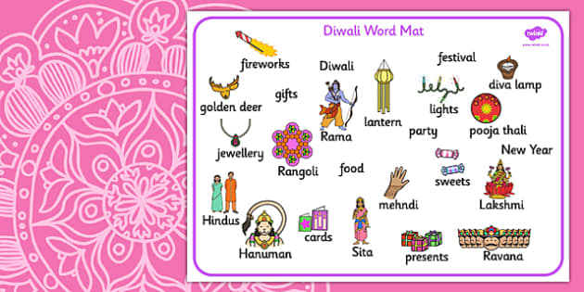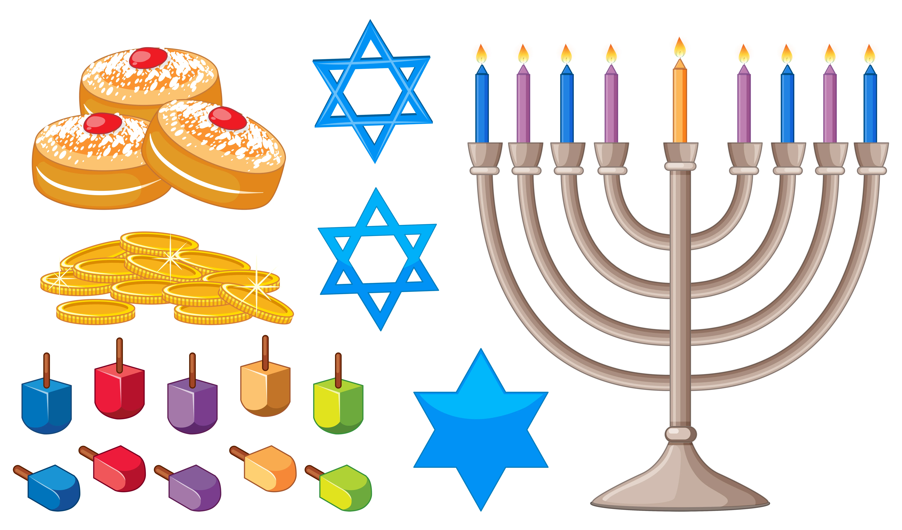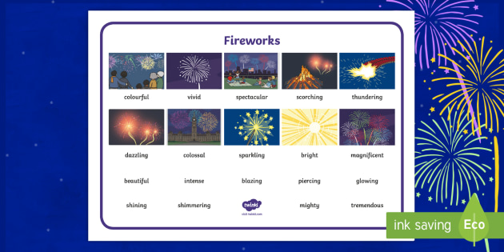

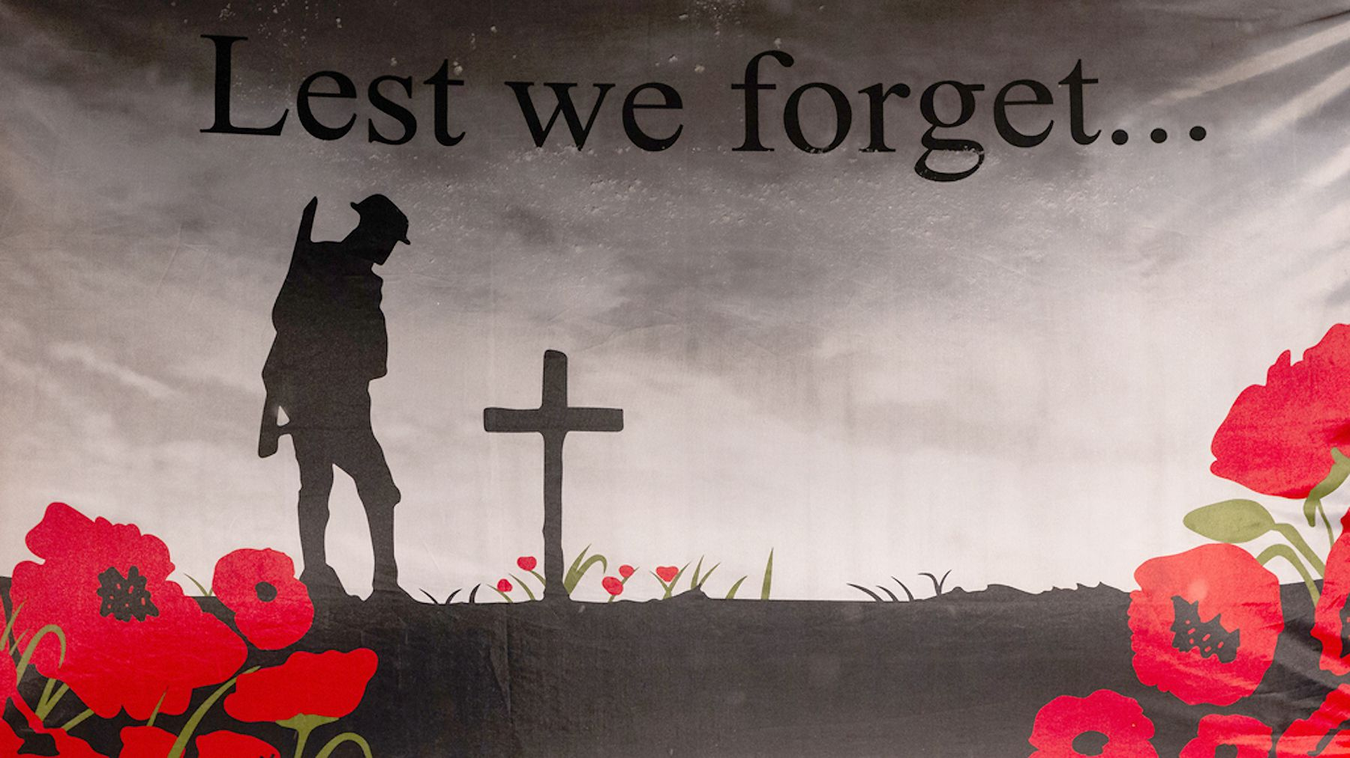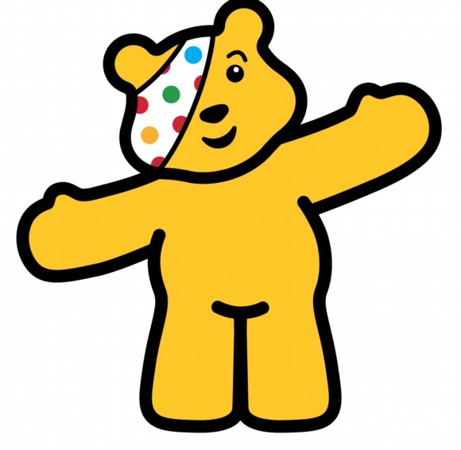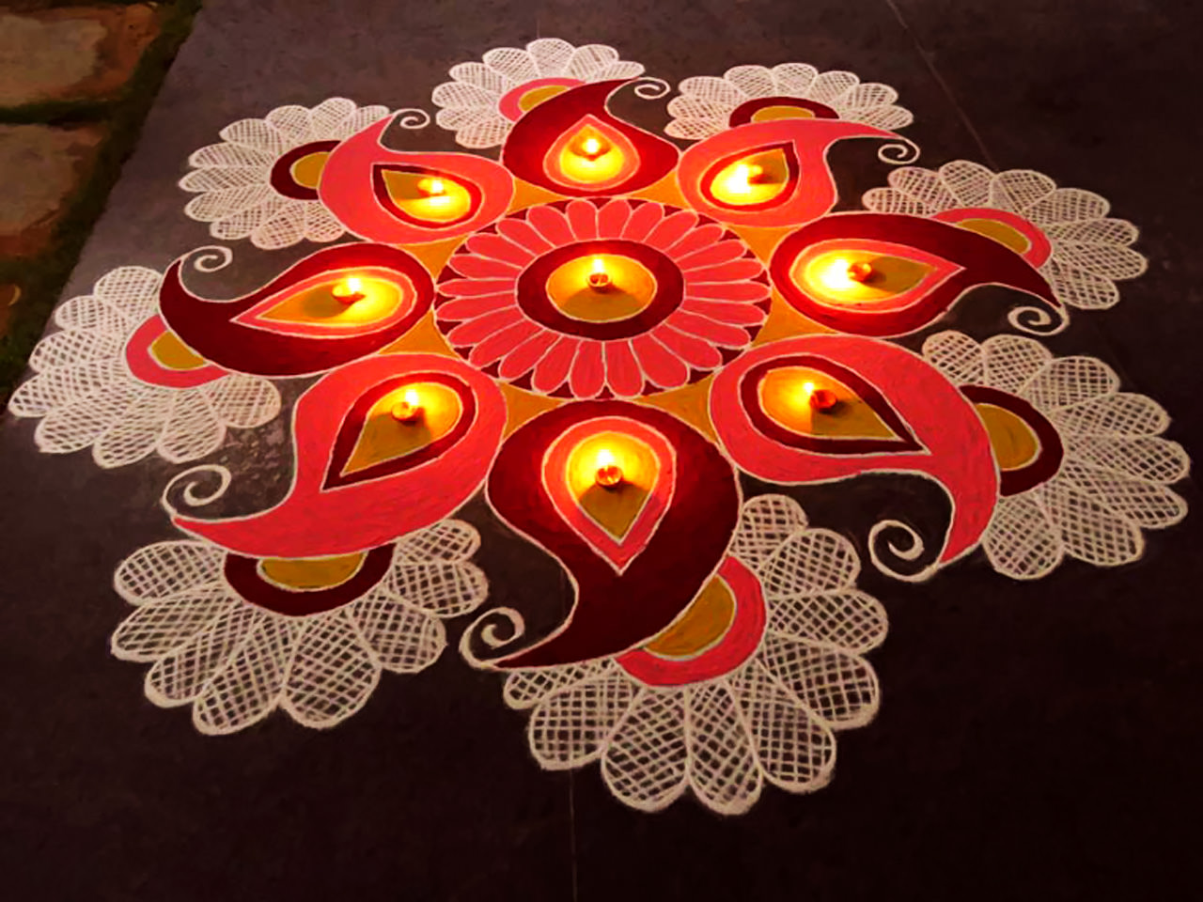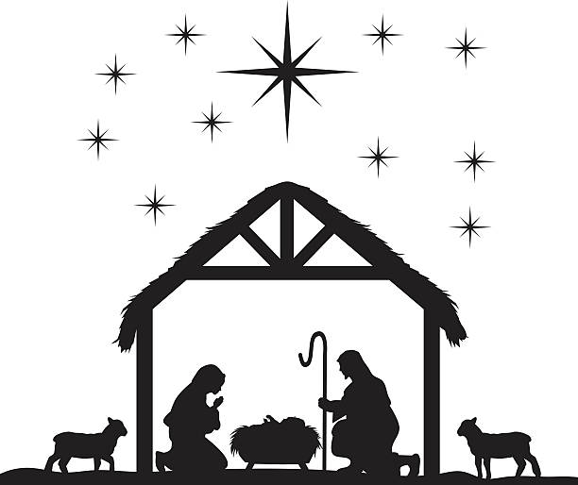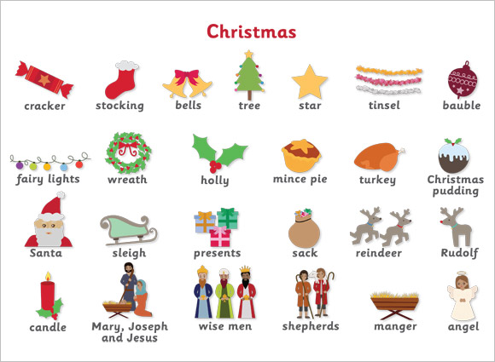

Vocabulary |  |  | Vocabulary |  |  |  |  |  | Vocabulary
Custom | A way of behaving or a belief that has been established for a long time | Hindu |  | Someone who follows  Hinduism. Hindus worship the God called Brahman |  |  |  | Disadvantaged |  |  | Lacking in the basic resources or condition believed to be necessary for an equal position in society
Celebration | A special event or occasion | Remembrance Day |  | Held on the second Sunday in November. A day to remember armed forces members who have died in the line of duty since the end of World War 1. |  |  |  | Black History Month |  |  | To recognise the contributions of Black people within history
Festival | A day or period of celebration | World War 1 |  | Started in 1914 and ended in 1918. Also known as the Great War |  |  |  | Advent |  |  | The four weeks leading up to Christmas. Starting on the nearest Sunday to 30th November.
Tradition | A belief or behaviour passed down special significance with origins in the past. | Poppy |  | A flower with 4-6 petals in various colours. Red poppies were the first flowers to bloom on WW1 battlefields |  |  |  | Nativity |  |  | The story from the Bible about the birth of Jesus
Worship | The feeling or act of showing respect, loyalty, or love | Hanukkah |  | Jewish Festival of Lights, celebrating a miracle in Jerusalem over 2000 years ago |  |  |  | Christmas |  |  | The Christian festival that celebrates the birth of Jesus. Christmas Day is celebrated on 25th December
Bonfire Night | A celebration on 5th November | Jewish |  | A person who practices Judaism |  |  |  | Christian |  |  | People who believe Jesus Christ is the Son of God and practice Christianity
Guy Fawkes | A man who tried to blow up the Houses of Parliament | Children in need |  | A charity that provides funding for disadvantaged young people in the UK |  |  |  | Boxing Day |  |  | December 26th. Originally a holiday where the poor were given gifts
Diwali | The Hindu Festival of Lights honouring Lakshmi, the goddess of wealth | Charity |  | An organization set up to provide help and raise money for those in need |  |  |  | New Year |  |  | The time or day at which a new calendar year begins
Curriculum links
Communication and language | PSED | Physical |  |  | Literacy |  | Mathematics |  |  | Understanding the world |  | Expressive art and design
Learn vocabulary connected to theme  Express feeling and experiences in regards to celebrations | Explore what a charity does  Recognise how others may feel  Understand rules and play team games | Develop overall body-strength,  balance, co-ordination and  agility  Can negotiate space during party games |  |  | Explore non-fiction and fiction books on celebrations and traditions  Write party invitations  Write Christmas cards |  | Use 2D and 3D shapes to create a bonfire, church, Christmas tree  Explore and create Rangoli patterns  Measure ingredients to make Christmas cookies  Count down to Christmas using an Advent calendar |  |  | Explore origins, rituals, traditions and celebrations  Explore different sources of light  Hibernation  Investigate ice  Go on a Winter walk |  | Create a diva lamp  Create a firework  Sing relevant songs and nursery rhymes  Design a Christmas jumper  Make Christmas cards and calendars

