All about me Autumn 1 Knowledge Organiser Reception - Seahorse Class
Key line of enquiry – Why do I need to keep my body healthy?
Task – Create a body map and name the different parts and functions.
I am special  - I can create a body map  - I can describe my feelings  - I can construct a family tree  - I can talk about people and objects that are special to me |  |  | My body  - I can name the different parts of the body and their functions  - I can explore my senses and describe them  - I can talk about the importance of sleep, exercising, and eating healthily |  |  |  |  | People who help us  - I can listen to visitors from our community  - I can ask relevant questions about different occupation  - I can compare occupations from the present and past
Key questions and focus
Can you remember a time when you have felt happy, sad, angry, or scared?  What can you do to help yourself when you are feeling….?  Who do you go to when you are feeling……?  Can you make a happy, sad, angry face?  How do you express your feelings?  What makes you special? |  |  | We will learn about our bodies and how they work.  We will observe the effects of activity on our bodies  Can you name some body parts?  What can we do to keep our bodies healthy?  What are the 5 senses?  What body parts are connected to the 5 senses?  What is inside our body?  How do you look after your teeth? |  |  |  |  | Can you name some occupations?  How do you contact someone from the emergency services?  What is different between a fireman now and a fireman from the past?  What do you think a fireman (etc) does?  What do you want to be when you grow up?  Do you know where the local police station (etc) is?
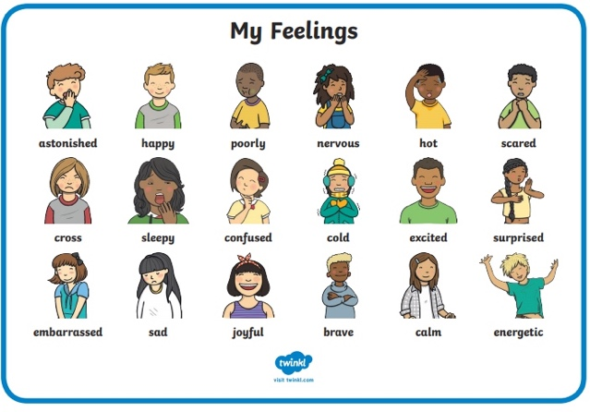 |  |  | 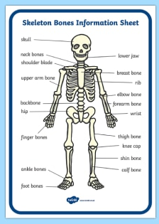  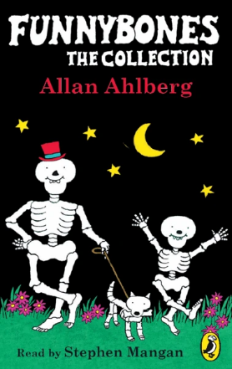 |  |  |  |  | 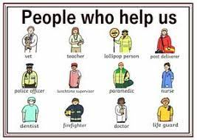
Vocabulary |  |  | Vocabulary |  |  |  |  | Vocabulary
Face parts | Hair, eyes, eyebrows, eyelashes, nose, nostrils, lips, mouth, chin, cheeks, ears | The five senses |  | Sight, hear, taste, smell, touch |  |  | Emergency Services |  |  | People who deal with problems
Feelings | Happy, sad, angry, excited, tired, scared, worried, surprised, embarrased | Body parts |  | Head, neck, shoulders, elbows, wrists, hands, fingers, tummy, back, hips, legs, knees, ankles, feet, toes |  |  | Ambulance |  |  | A vehicle that takes people to hospital
Unique | One of a kind | Exercise |  | Moving to keep our bodies fit and healthy |  |  | Fire Engine |  |  | Vehicle that has lots of equipment to help put out fires
Different | Not the same | Healthy |  | Well, not ill or sick |  |  | Hospital |  |  | A large building where people go to get better
Similar | Almost the same | Germs |  | Bacteria that can make us ill |  |  | Community |  |  | All the people who live in a particular area
Identical | Exactly the same | Skeleton |  | The bones that are inside our bodies |  |  | Emergency |  |  | A serious or dangerous event
Body map | Create a body and label it | Heart |  | An organ inside our bodies that pumps our blood |  |  | Rescue |  |  | Saving someone in danger
 |  | Lungs |  | An organ inside our bodies that helps us breathe |  |  | Assistance |  |  | Help or support
Curriculum links
Communication and language | PSED | Physical |  |  | Literacy | Mathematics |  |  | Understanding the world |  | Expressive art and design
Discuss ‘This is me’ bags  Ask questions of people who help us visitors  Learn vocabulary connected to theme | Discuss our special objects and events in our ‘This is me’ bag  Express their feelings and consider the feelings of others  Identify and moderate their own feelings socially and emotionally. | Develop overall body-strength,  balance, co-ordination and  agility  Further develop the skills they  need to manage the school  day successfully:  Know and talk about the  different factors that support  their overall health and  wellbeing |  |  | Explore non-fiction and fiction books on the body  Begin to write my name  Listen to Golden Rules stories  Label a skeleton  Blend sounds into words | Compare size, height, length  Measure different parts of the body  Compare children’s features  Recognise patterns in children’s features  Learn our birthday date |  |  | Use senses on a nature walk  Touch-Feely boxes  Taste- Acrimboldo faces  Smell- smelly playdough  Hear- sounds walk  Sight- Kim’s game  Talk about members of their immediate family and community  Understand that some places  are special to members of  their community |  | Draw a self portrait  Create a skeleton using cotton buds/straws  Acrimboldo faces – use fruits and vegetables to make faces

