Hinguar Primary School and Nursery - SECAT
Knowledge Organiser
Art – Soap Carvings / African Masks  3D and Printing | Year 6 | Summer Term |  | Topic: Benin
Prior Knowledge |  | Application of Knowledge
Printing -  - Choose the printing method appropriate to task.  - Build up layers and colours/textures.  - Organise their work in terms of pattern, repetition, symmetry or random printing styles.  - Choose inks and overlay colours.  3D -  - Clay- Use clay to model an idea. Reinforce and adapt joining techniques and understanding of from.  - Construction- Use recycled, natural and man-made materials to create sculpture focused on form and relation to space.  - Plan a sculpture through drawing and other preparatory work.  Key Hinge Questions  - What do you know about Benin artwork?  - How could you use clay to produce an African mask?  - What did you like about your artwork?  - How can you improve your artwork? |  | Benin art is the art from the Kingdom of Benin or Edo Empire (1440–1897), a pre-colonial African state located in what is now known as the South-South region of Nigeria. This original significance is of great importance in Benin.  The Kingdom of Benin has produced some of the most renowned examples of African art. There are an estimated 2,400 to 4,000 known objects including 300 bronze heads, 130 elephant tusks, and 850 relief plaques.  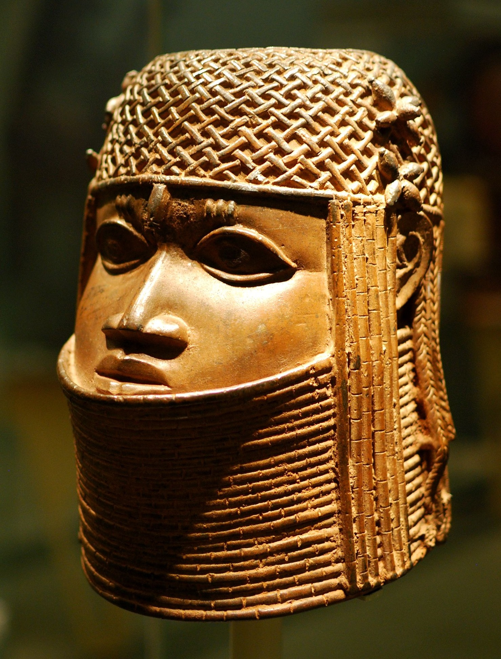  Printing -  - Describe varied techniques.  - Be familiar with layering prints.  - Be confident with printing on paper and fabric.  - Alter and modify work.  - Work relatively independently.  3D -  - Clay-Develop skills in using clay including slabs, coils, slips, etc.  - Construction-Create sculpture and  - constructions with increasing  - independence.
What will I know by the end of this topic? |  | Key Vocabulary
Recognise African artwork.  Able to produce an African mask.  Use a sketch book to collect and record observations.  How to use a variety of tools to produce required artwork.  How to review what they and others have done and say what they think and feel about it. |  | Sculpture | The art of making 2 or 3D representative or abstract forms, especially by carving stone or wood or by casting metal or plaster.
 |  | Clay | A stiff, sticky fine-grained earth that can be moulded when wet is dried and baked to make bricks, pottery, ceramics.
 |  | Printing | Printmaking is an artistic process based on the principle of transferring images from a matrix onto another surface, most often paper or fabric.
 |  | Technique | A way of carrying out a particular task, especially the execution or performance of an artistic work or a scientific procedure.

