Hinguar Primary School and Nursery - SECAT
Knowledge Organiser
Art – Royal Portraits / Nicholas Hillard  Painting | Year 6 | Spring Term |  | Topic: Crowns and Coronets
Prior Knowledge |  | Application of Knowledge
Painting -  - Control and experiment with particular qualities of tone, shade, hues and mood.  - Create shades and tints using black and white.  - Work on preliminary studies to test media and materials.  - Create imaginative work from a variety of sources.  - Show an awareness of how paintings are created (composition)  Key Hinge Questions  - Who is Nicholas Hilliard?  - Do you know of any other artists that work in miniature?  - How to produce your own miniature artwork.  - What did you like about your artwork?  - How can you improve your artwork? |  | Nicholas Hilliard (1547-1619) trained as a goldsmith and became an outstanding painter of portrait miniatures, the first notable English artist of this medium.  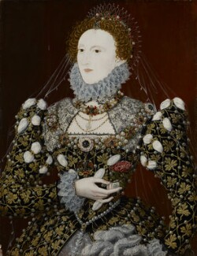  Painting -  - Demonstrate a secure knowledge about primary and secondary, warm and cold, complementary and contrasting colours.  - Consider the composition and choose appropriate paint, paper, colour and implements to adapt and extend their work.  - Carry out preliminary studies, test media and materials and mix appropriate colours.  - Work from a variety of sources, inc. those researched independently.
What will I know by the end of this topic? |  | Key Vocabulary
Who Nicholas Hilliard is and his type of artwork.  Draw and paint a self-portrait.  Use a sketch book to collect and record observations.  How to use a variety of tools to produce required artwork.  How to review what they and others have done and say what they think and feel about it. |  | Complementary colours | Pairs of colours that contrast with each other more than any other colour, and when placed side-by-side make each other look brighter.
 |  | Contrasting colours | Colours that are directly across from one another on a basic colour wheel provide maximum contrast
 |  | Miniature | Something that is much smaller than normal, especially a small replica or model.
 |  | Portrait | A painting, drawing, photograph, or engraving of a person, especially one depicting only the face or head and shoulders.
 |  | Self-Portrait | A portrait that an artist produces of themselves.

