Hinguar Primary School and Nursery - SECAT
Knowledge Organiser
Art – Flying Machine  Leonardo da Vinci | Year 5 | Spring Term |  | Topic: Up, Up and Away
Prior Knowledge |  | Application of Knowledge
Drawing -  - Make informed choices in drawing inc. paper and media.  - Alter and refine drawings and describe changes using art vocabulary e.g. line, shade, form.  - Use research to inspire drawings from memory and imagination.  - Explore relationships between line and tone, pattern and shape, line and texture.  - Identify and draw the effect of light.  Key Hinge Questions  - Who is Leonardo da Vinci?  - What are the different styles of Norse art?  - What did you like about your artwork?  - How can you improve your artwork? |  | Leonardo da Vinci was an Italian polymath of the High Renaissance who was active as a painter, draughtsman, engineer, scientist, theorist, sculptor and architect.  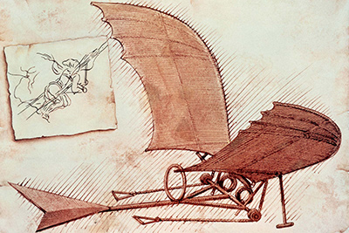  Drawing -  - Use a variety of source material for their work.  - Work in a sustained and independent way from observation, experience and imagination.  - Show awareness of form within observed work.  - Explore the potential properties of the visual elements, line, tone, pattern, texture, colour and shape to embody ideas and serve their needs.
What will I know by the end of this topic? |  | Key Vocabulary
Who Leonardo da Vinci is and recognise and critic his artwork.  Create a sketch drawing similar to da Vinci’s ‘Flying Machine’  Use a sketch book to collect and record observations.  How to use a variety of tools to produce required artwork.  How to review what they and others have done and say what they think and feel about it. |  | Leonardo da Vinci | A famous painter who painted one of the world’s most famous portraits the ‘Mona Lisa’
 |  | Sketch | A sketch is a rapidly executed freehand drawing that is not usually intended as a finished work.
 |  | Tone | Light and dark values.
 |  | Line | Straight or curved marks between two points.
 |  | Texture | The surface of the artwork.

