Hinguar Primary School and Nursery - SECAT
Knowledge Organiser
Art – Norse Art and Symbols  3D and Printing | Year 5 | Autumn Term |  | Topic: Invaders and Settlers
Prior Knowledge |  | Application of Knowledge
Printing -  - Research, create and refine using a variety of techniques.  - Select broadly the kinds of material to print with in order to get the effect they want  - Resist printing including marbling, silkscreen and coldwater paste.  3D -  - Clay- Construct a simple coil pot or use the technique of coiling to model in clay. Consolidate techniques of joining clay (slip)  - Construction Make informed choices about the 3D technique chosen.  - Show an understanding of shape, space and form.  - Plan, design, make and adapt models.  Talk about their work understanding that it has been sculpted, modelled or constructed  Key Hinge Questions  - What is Norse art?  - What are the different styles of Norse art?  - What did you like about your artwork?  - How can you improve your artwork? |  | Viking art, also known commonly as Norse art, is a term widely accepted for the art of Scandinavian Norsemen and Viking settlements further afield—particularly in the British Isles and Iceland—during the Viking Age of the 8th-11th centuries.  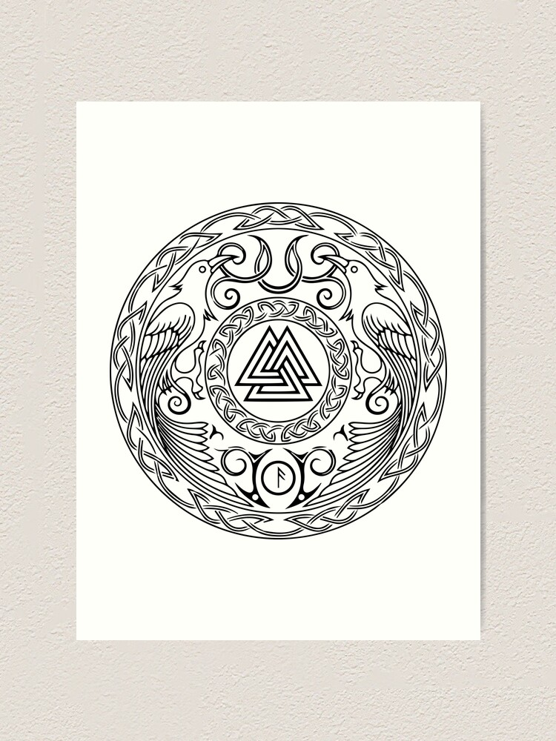  Printing -  - Choose the printing method appropriate to task.  - Build up layers and colours/textures.  - Organise their work in terms of pattern, repetition, symmetry or random printing styles.  - Choose inks and overlay colours.  3D -  - Clay- Use clay to model an idea. Reinforce and adapt joining techniques and understanding of from.  - Construction- Use recycled, natural and man-made materials to create sculpture focused on form and relation to space.  - Plan a sculpture through drawing and other preparatory work.
What will I know by the end of this topic? |  | Key Vocabulary
Recognise Norse Art and symbols.  Create original piece of Norse artwork using clay.  Recognise patterns within Norse art.  Use a sketch book to collect and record observations.  How to use a variety of tools to produce required artwork.  How to review what they and others have done and say what they think and feel about it. |  | Norse Art | Also known as Viking art using six different styles.
 |  | Natural materials | A natural material is any product or physical matter that comes from plants, animals, or the ground.
 |  | Man-made materials | Materials obtained from natural materials through chemical processes. These materials are usually made using natural, and raw materials - glass, nylon, paper, steel, synthetic rubber, polyester, wax paper, concrete, and silicone rubber.
 |  | Sculpture | the art of making two- or three-dimensional representative or abstract forms, especially by carving stone or wood or by casting metal or plaster.
 |  | Symmetry | When the elements of a painting or drawing balance each other out.

