Hinguar Primary School and Nursery - SECAT
Knowledge Organiser
Art – Drawing &  Computer generated drawings | Year 4 | Spring Term |  | Topic: Making Waves
Prior Knowledge |  | Application of Knowledge
Drawing -  - Experiment with different grades of pencil and other implements. Investigate tone by drawing light/dark.  - Use drawing as a means of designing, developing fantasy ideas.  - Draw for a sustained period of time at their own level.,e.g. observation from a single figure, objects or grouped objects.  - Plan, refine and alter their drawings as necessary.  - Use different media to achieve variations in line, texture, tone, colour, shape and pattern from what they observe.  Key Hinge Questions  - What is animation?  - What is meant by stop frame animation?  - What did you like about your artwork?  - How can you improve your artwork? |  | 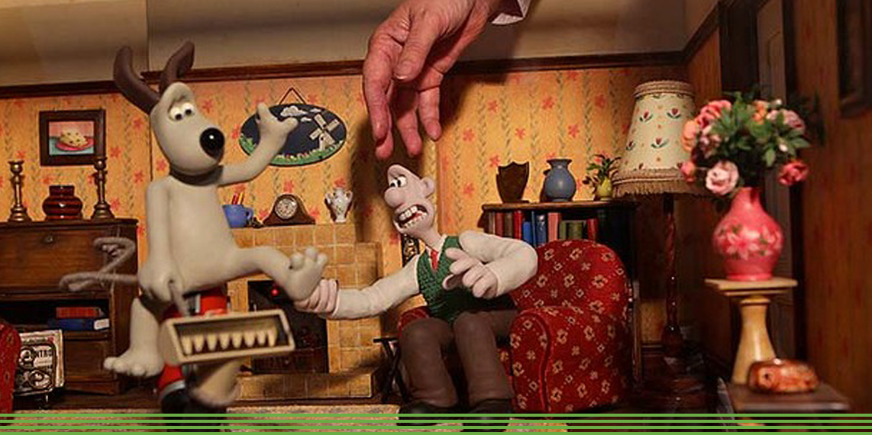  - Make informed choices in drawing inc. paper and media.  - Alter and refine drawings and describe changes using art vocabulary e.g. line, shade, form.  - Use research to inspire drawings from memory and imagination.  - Explore relationships between line and tone, pattern and shape, line and texture.  - Identify and draw the effect of light.  - Investigate animation and computer-generated drawings.  - Use Stop Frame / Light Box / Animation / Film.
What will I know by the end of this topic? |  | Key Vocabulary
How to use an animation programme.  How to produce a computer-generated drawing.  Use tone, line and shade within drawings.  Use a sketch book to collect and record observations.  How to use a variety of tools to produce required artwork.  How to review what they and others have done and say what they think and feel about it. |  | Line | Straight or curved marks between two points.
 |  | Tone | Light and dark values.
 |  | Texture | The surface of the artwork.
 |  | Light | Using low pressure when mark making.
 |  | Dark | Using high pressure when mark making.
 |  | Animation | The visual art of making a motion picture from a series of still drawings.

