Hinguar Primary School and Nursery - SECAT
Knowledge Organiser
Art - Roman Mosaic Tessellation/Pattern | Year 4 | Autumn Term |  | Topic: Emperors and Empires
Prior Knowledge |  | Application of Knowledge
Printing -  - Print using a variety of materials, objects and techniques including, string, polystyrene, (relief) layering (over printing).  - Talk about the processes used to produce a simple print.  - Explore pattern and shape, creating designs for printing. e.g., building up shapes and patterns, overprinting.  3D -  - Clay- Construct a simple clay tile and extend this by adding and modelling other shapes on to it.  - Join clay adequately and work reasonably independently.  - Construction Make a simple papier mache object.  - Plan, design and make models using re-cycled, natural or manmade materials.  Key Hinge Questions  - What are Roman mosaics?  - What is tesserlation?  - What did you like about your artwork?  - How can you improve your artwork? |  | The floors of Roman buildings were often richly decorated with mosaics – tiny coloured stones (tesserae)  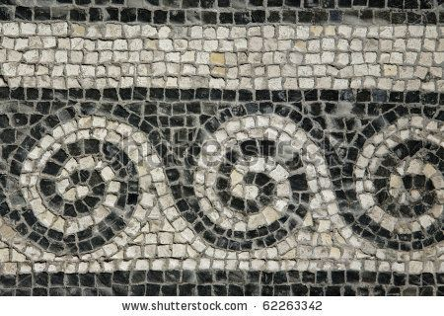  Printing -  - Research, create and refine using a variety of techniques.  - Select broadly the kinds of material to print with in order to get the effect they want  - Resist printing including marbling, silkscreen and coldwater paste.  3D -  - Clay- Construct a simple coil pot or use the technique of coiling to model in clay. Consolidate techniques of joining clay (slip)  - Construction Make informed choices about the 3D technique chosen.  - Show an understanding of shape, space and form.  - Plan, design, make and adapt models.  - Talk about their work understanding that it has been sculpted, modelled or constructed
What will I know by the end of this topic? |  | Key Vocabulary
What Roman mosaics look like and how they are created.  A variety of ways of printing.  How to make a coil pot.  What tessellation is.  Use a sketch book to collect and record observations.  How to use a variety of tools to produce required artwork.  How to review what they and others have done and say what they think and feel about it. |  | Resist Printing | A technique for printing colour on fabric, where a resist paste or material is imprinted on the fabric and then dyed.
 |  | Marbling | Colouring or marking that resembles marble,
 |  | Silkscreen | A sophisticated stencilling technique for surface printing, a design is cut out of paper or another thin, strong material and then printed by rubbing, rolling, or spraying paint or ink through the cut out areas.
 |  | Coiling | A method of creating pottery. ... To do this, the potter takes a pliable material (usually clay) then rolls it until it forms a coil, or long pliable cylinder. By placing one coil on top of another, different shapes can be formed
 |  | Slip | A clay slurry used to produce pottery and other ceramic items.

