Hinguar Primary School and Nursery - SECAT
Knowledge Organiser
Art – Henri Rousseau Tiger in a Tropical Storm  Painting / Collage | Year 3 | Summer Term |  | Topic: Rumble in the Jungle
Prior Knowledge |  | Application of Knowledge
Painting -  - Develop awareness of the variety and qualities of colour in their environment.  - Mix a range of secondary colours, shades and tones.  - Experiment with tools and techniques, including, layering and mixing media.  - Identify the primary colours by name.  - Mix the primary shades and tone.  - Identify warm and cold colours.  - Work on a range of scales – large brush on large paper.  - Mix and match colours using artefacts and objects.  Textile & Collage -  - Cut and shape fabric using scissors/snips. Apply shapes with glue or stitching.  - Introduce sewing – how to thread a needle, simple running stitch and knot.  - Sort and group materials for different purposes e.g. colour, texture.  - Fold, crumple, tear and overlap techniques.  - Create textured collages from a variety of media.  Key Hinge Questions  - Who is Henri Rousseau?  - What is your opinion of ‘Tiger in a Tropical Storm’?  - What did you like about your artwork?  - How can you improve your artwork? |  | Henri Julien Félix Rousseau was a French post-impressionist painter in the Naïve or Primitive manner.  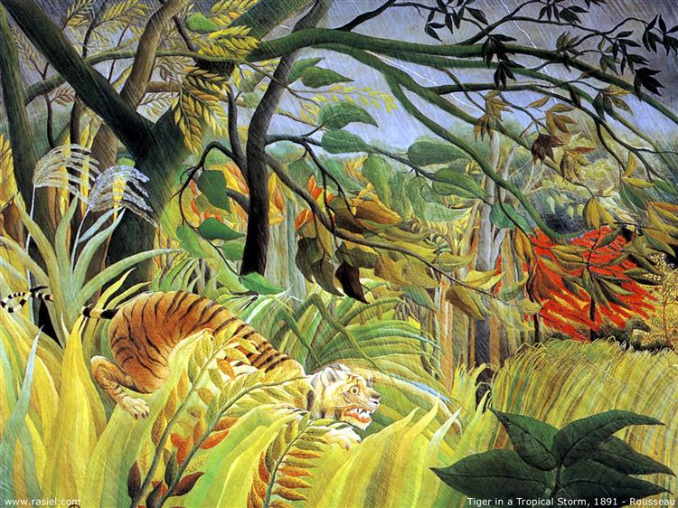  Painting -  - Mix a variety of colours and know which primary colours make secondary colours.  - Use a developed colour vocabulary so pupils can describe and identify the use of hot, warm, cool, cold and complimentary colours  - Use colour to express and describe a feeling.  - Experiment with different effects and textures inc. blocking in colour, washes, thickened paint etc.  - Work confidently on a range of scales e.g. thin brush on small picture etc.  Collage -  - Textile Use the technique tie-dyeing and fabric crayons.  - Develop skills in stitching: back, cross, herringbone  - Collage Experiment with a range of media e.g. overlapping, layering etc.
What will I know by the end of this topic? |  | Key Vocabulary
Who Henry Rousseau is and identify his artwork.  Use a sketch book to collect and record observations.  How to use a variety of tools to produce required artwork.  How to review what they and others have done and say what they think and feel about it. |  | Post-Impressionist | An art movement that developed in the 1890s, characterized by a subjective approach to painting, as artists opted to evoke emotion rather than realism in their work.
 |  | Primary colours | A group of colours from which all other colours can be obtained by mixing. Red/Yellow/Blue
 |  | Secondary colours | A colour resulting from the mixing of two primary colours. Purple/Orange/Green
 |  | Collage | A piece of art made by sticking different materials onto a backing.
 |  | Textile | A type of cloth or woven fabric.

