


Southend East Community Academy Trust
Hinguar Primary School and Nursery

Proposed Admissions Arrangements (Policy) – 2021/22

Hinguar Primary School is an academy and forms part of the group of schools under Southend East Community Academy Trust These arrangements are in line with government legislation and guidance (School Admissions Code 2014) and designed to ensure there is a fair, clear and reasonable admissions procedure for all applicants, and to help guide parents through the application process. These arrangements apply to all admissions, including in-year admissions.

The Planned Admissions Number (PAN) at Hinguar Primary is 30 pupils in each year group.
Applying for a place
Hinguar Primary School welcomes all applications. We have one main intake in September and we try to encourage entry at this time in order to support the child's academic progression without interruption, however, parents can apply at any time.
Parents are encouraged to visit the school with their child if they are planning to apply for a place and we have a number of open days for new Reception parents during the year. Arrangements for visits outside of these dates can be made through the school office.

Admission for the main round to reception, year 3 and year 7, for children transferring to secondary, is run according to the published admissions scheme and a short version of this policy are available on the Council’s web site, in the Primary Admission Booklet.

Applications for Reception can be made online at http://www.southend.gov.uk/admissions See below for in-year admission.
Oversubscription
If at the closing date for applications, there are not enough places for all those who have expressed a wish to have their child admitted to the school; places will be allocated using the admission criteria as below. This will not apply to children with a statement of special educational needs (SEN) or Education, Health and Care (EHC) plans as the plan/statement names the school and therefore the child must be admitted to the named school. The admission criteria are listed below with explanatory notes following:
a) Looked after children and previously looked after children;
b) Children who live in the catchment area who have a sibling attending the school
c) Children who live in the catchment area;
d) Children who live outside the catchment area who have a sibling attending the school
e) Children who live outside the catchment area.
(for all criteria, catchment area map and additional information please see explanatory notes and catchment map below)

Explanatory and additional notes:
Parents must make a separate application for transfer from nursery to infant/primary school. Parents must complete a Southend-on-sea Common Application Form (CAF) for applications to year reception between 14th September and 15th January.

Pupils in public care and children that were previously in public care
Any reference to looked after children refers to children who are in the care of local authorities as defined by Section 22 of the Children Act 1989. In relation to school admissions legislation a ‘looked after child’ is a child in public care at the time of application to the school’. Any reference to previously looked after children means children who were adopted (or subject to child arrangements order) immediately following having been looked after. Looked after and previously looked after children are given the highest priority for each relevant age group and in all ranking.

Measuring tool:
In the case of over subscription in any one category “straight line” distance will be used to measure the distance between the pupil’s home (including flats) and the nearest pupil entrance to the school. Distances will be measured using the Local Authority’s computerised measuring system. The pupils living closest will be given priority.

Tie-Break
to be used to decide between two applications that cannot otherwise be separated: If the same distance is shared by more than one pupil, and only one place is available, the place will be awarded on the basis of a computerised random allocation process (supervised by someone independent of the Council / governing body). In the case where the last child offered is a twin or sibling of a multiple birth sibling both/all children will be offered and the sibling will be an ‘excepted pupil’.

Distance where parents have separated
The distance is measured the same for all applications. Only one application can be received. The LA should not have the details of both parents or know of the marital status of the parents. If more than one application is received from parents, applications will be placed on hold until such time that:
- an application is made that both parents agree to; or
- written agreement is provided from both parents; or
- a court order is obtained confirming which parent's application takes precedence’.
Details on address checks and which address is relevant are also provided in the admission booklet. In all cases the child’s normal place of residence is applicable for the purposes of the application.
Siblings:
Siblings are considered to be an older brother or sister, half-brother or half-sister, step-brother or step-sister, adopted brother or sister, living at the same address, who attends the school at the time of application with a reasonable expectation that he or she will still be attending at the time of the proposed admission. In every case, the child should be living in the same family unit at the same address. In the exceptional situation where one twin or one or two triplets are refused a place, in order to keep family members together the additional pupil(s) will be admitted even if this results in the admission limit for the year group being exceeded (2.15 g) The school admission code).
Children with a statement of Special Educational Needs (SEN) or Education, Health and Care Plan (EHCP)
The school will admit all children who have a SEN statement or EHCP where this school named.
Children who have Special Educational Needs but who do not have a SEN statement or EHCP will be treated equally to all other applicants in the admissions process. This includes children who may need extra support or reasonable adjustments to be made. The school will do everything it can to accommodate these pupils. See our SEN Local Offer for details of special provision provided by the school.

Waiting list
Children’s names will automatically be on the waiting list for the school if it is higher on the rank list and where they do not receive an offer for all year groups. The list will set out the priority for places in the same order set out in the oversubscription criteria. Each added child will require the list to be ranked again in line with the published oversubscription criteria The child may gain entry to the school if the number of pupils falls below the admissions limit of the school. If a child on the waiting list is offered a position at the school, they will be notified and will have the option of accepting or rejecting the place within 10 days. In limited situations it may be appropriate to admit to the start of the next term (as per the Education Act 2006) this will be to give the Academy the opportunity to put measures in place for the admission. This will only apply to children already in a school and not for any unplaced pupils. . The school has commissioned the local authority to maintain and manage the school waiting lists.
Changes to admission arrangements
The admission arrangements for the school may be changed by the admission authority in accordance with the requirements of the relevant legislation. Parents will be consulted on any changes in line with the legislation as appropriate.
Address:
For all applications the address used will be the child’s habitual normal place of residence as at the closing date for applications, i.e., 15th January (reception and year 3). Changes to address will be updated after all on time applications have been processed.
Parents must notify the School admissions team at Southend-on—Sea Borough Council immediately if there are any changes that may affect their child’s application, such as a change of address for the main round to reception or year 3. If the child lives at more than one address, it is the address where the child lives for the majority of the school week that will apply. Details on address checks and verification by the council can be found in the admission booklets on the Councils website. (see further details on address check in the Primary Admissions Booklet on www.southend.gov.uk/admissions).

In-year admissions
To apply for a place at the school during the school year or for transfer to a year group parent can apply using via the local authority. The form is available on www.southend.gov.uk/admissions and select in-year.
.
Fair Access Protocol
Hinguar Primary works with the LA in accordance with their in-year Fair Access Policy in order to ensure that pupils with additional needs or who may present challenges are not disproportionally admitted to one school or year group. Southend’s Fair Access Protocol includes a number of categories which identify a child as being potentially vulnerable or likely to present a challenge to the school. These include (but are not restricted to) previous behaviour issues and poor attendance; details are available in the Fair Access Protocol.

Appeals
Parents or carers can appeal to the independent appeal panel against refusal of admission to the school. A child is allowed to be on the school waiting list while lodging an appeal and the appeal will not affect their position on the list. The decision of the appeals panel is binding on the admissions authority. Parents can appeal by completing the appeal from and submitting it to the local authority. Further details can be found on: https://www.southend.gov.uk/info/200176/school_admissions_and_home_education/49/school_admission_appeals or request an appeal form on admissions@southend.gov.uk

Over and Under age applications
Parents may seek a place for their child outside of their normal age group, (usually during the school year and not at the point of admission), for example, if the child is gifted and talented or has experienced problems such as ill health. In addition, the parents of a summer born child may choose not to send that child to school until the September following their fifth birthday and may request that they are admitted out of their normal age group – to reception rather than year 1. All other applications for over or under age in-year will be handled in line with the School Admissions Code 2014, 2.17 (a & b).
Such requests are made initially informally in discussions with the Head Teacher and where parents wish to proceed with the request a written letter with any relevant documentation should be provided to the Head Teacher. The School would make decisions on the basis of the circumstances of the individual case and will be in the best interests of the child.

Requests for in year 3 and 6 must have been submitted by the parent and considered by the admission authority before the closing date for applications to year 7, i.e. 31 October (secondary) and 15 January (primary) of any given year. When informing a parent of their decision on the year group the child should be admitted to, the admission authority must set out clearly the reasons for their decision. In circumstances where a child transfers from another school already ‘outside of normal age group’ , the Academy will support any over or under age application where the above has been met and the Academy is satisfied that the child should continue to be educated out of normal age group.

A parent cannot appeal against refusal to the ‘out of normal age group’ application.

Admission of children below compulsory school age and deferred entry to school/
Most children start school on a full time basis, however parents can request that their child attends part time until reaching compulsory school age (the term after their 5th birthday). Once parents receive an offer and accept a place for their child during the normal admission round they can ask to defer the admission until later in the same academic year. The school will aim where possible to accommodate these requests where it appears to be in the best interest of the child. Parents wishing their child to attend part time they must discuss this with the headteacher of their allocated school. The approved deferred means that the place is held open and is not offered to another child and the parents must take up the place full time by the start of the Summer Term in April. Part-time agreements should include core teaching.
In the case of children born prematurely or the late summer months parents may request admission outside the normal age group. There is no statutory barrier to children being admitted outside their normal year group (DfE Guidance, Dec 2014). Due to the impact on future years for a child’s schooling, requests to delay admission are very carefully considered by both the admitting authority and the parents. The decision to admit outside of a child’s normal age group is made on the basis of the circumstances of each case. Any decision will seek a decision in the best interest for the child and be considered by the Head Teacher/SLT.
Such requests are made initially informally in discussions with the Head Teacher and where parents wish to proceed with the request a written letter with any relevant documentation should be provided to the Head Teacher.

Parents submitting a request for admission outside the normal age group must also complete the Single application Form during the main admission round, 14th September – 15th January for the ‘usual age group for their child’.

Catchment areas:
A look up postcode list is available on www.southend.gov.uk/admissions and a map is provided below:

School Catchment Area for Hinguar Primary School
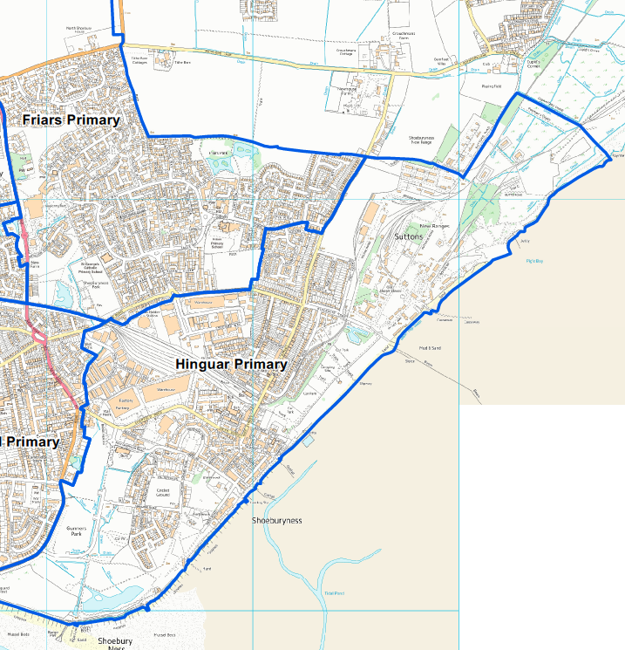

For office use – statutory process: The School Admissions Code 2014
15 October 2019 - 26 November 2019 | Statutory consultation period in line with The school admission Code 2014
27 Nov – 27 Feb | Trust and School consider outcome of consultation and finalise arrangements
28th February 2020 | Final Determined Admission Arrangements 2021/22 approved by Trust  Determined Admission Arrangements 2021/22 send to the LA.  LA publish composite prospectus.
15th March 2020
16th March – 15th May 2020 | Window for Objections to the School Adjudicator
1st September 2020 | Final arrangements for 2021 are published in the Secondary booklet

